Virtual ATM (Final)

Team Sudoers

Raysean Jones-Dent, Tonye Andre Martial, Matthew Mitchell, Kristine Dudley, Woo Choi, Justin Kim

May 13, 2019

CMSC 495 7982

Dr. Janell Robinson

University of Maryland University College

Table of Contents

Overview 4

Project Plan 4

Team Roles 4

Project Milestones 4

Requirements Specification 5

System Specification 6

Software Management 6

Functionality 6

User Interface 6

Miscellaneous 7

Languages 7

Security 7

User’s Guide 8

How to Login 8

How to Change Language 8

Homepage 9

How to Withdraw Funds 9

How to Deposit Funds 10

How to Transfer Funds 11

How to Check the Balance of an Account 12

How to Check Account History 12

How to Logout 12

Test Plan and Results 13

Test Result Screenshots 16

Design and Alternate Designs 16

Design Summary 16

Data Structures and Data Types 16

Input and Output Formats 17

Classes, Methods, Fields, Interfaces, FXML 17

UML Class Diagram 23

User Interface Layer 24

Data Access Layer 26

Alternate Design 27

Development History 32

Modifications 32

Lessons Learned 33

Design Strengths 33

Limitations 33

Suggestions for Future Improvement 34

# Overview

Over the period of eight weeks, Team Sudoers have researched, planned, designed, built, and tested a virtual Automated Teller Machine (ATM) application. With an emphasis on conceptual integration, practical application, and design aesthetics, our team has developed a banking application with cutting-edge properties, reliable security measures, and multiple language options.

# Project Plan

## Team Roles

Weekly leads have been assigned and can be seen in the Project Milestones table. Work will be evenly distributed throughout the project and each member will maintain constant communication with the rest of the team. Weekly meetings will be held every Tuesday night via Skype.

## Project Milestones

|  |  |  |  |
| --- | --- | --- | --- |
| **Tasks** | **Start Date** | **End Date** | **Lead** |
| Develop Project Plan- Establish requirements, determine weekly leads & roles | March 25, 2019 | March 31, 2019 | Justin |
| Develop User Guide & Test Plan, establish test cases | April 1, 2019 | April 7, 2019 | Kristine |
| Peer Review 1 | April 1, 2019 | April 7, 2019 | ALL |
| Project Design- Develop coding framework & UI design, UML class diagram, XML entities | April 8, 2019 | April 14, 2019 | Tonye |
| Peer Review 2 | April 15, 2019 | April 21, 2019 | ALL |
| Phase 1 Source- Begin initial GUI coding & documentation | April 15, 2019 | April 21, 2019 | Raysean |
| Phase 2 Source- Complete GUI & begin coding backend (ATM transactions, language setting) | April 22, 2019 | April 28, 2019 | Matthew |
| Phase 3 Source- Finalize system specifications, begin testing & debugging. | April 29, 2019 | May 6, 2019 | Woo |
| Peer Review 3 | May 7, 2019 | May 12, 2019 | ALL |
| Final Deliverables- Organize documentation, finalize deliverables (code, citations, etc.) | May 7, 2019 | May 12, 2019 | Justin |

# Requirements Specification

Our ATM project will simulate a virtual ATM machine where users may conduct ATM transactions for: withdrawing, depositing, transferring, and viewing account history. Our GUI application will be developed using Java 8.0. The program will start with a login page where the user may input their username and PIN number. The login page will also provide an option to “Change Language”. Once logged in, the GUI will display the balances for both the checking, savings, and last transaction. This menu will have buttons where the user may select the transactions listed above as well as an option to “View Transaction History” or “Logout”.

Our program will include a .xml file with a list of active users and their information so that we can effectively test our program. When logging in, the program will import that user’s data from the .xml file in the project folder. We will also conduct tests on various scenarios which will utilize all the program’s functions. This will include stress tests such as multiple transactions.

# System Specification

Our GUI application will be developed using Java 8.0 with the NetBeans 8.2 IDE. We will use the JavaFX platform to build the user interface for the program. We will use XML to store user accounts, bank accounts, and transaction information. The documentation will be written via Microsoft Word. We will also use Google Drive and GitHub’s repository to share work amongst the team members.

## Software Management

Version control will be managed through our group’s GitHub repository:

<https://github.com/team-sudoers>

## Functionality

### User Interface

* Home page functions for currently logged in user
  + How does the user pick the account they want to perform the transaction on?
    - Banking function buttons will have a prompt when selected
  + How many accounts can we display?
    - Checking and savings
  + What exact banking functions are allowed?
    - Two account types (checking and savings)
    - Balance Inquiry (visible at log-in)
    - Withdrawal (checking and savings)
    - Deposit (checking and savings)
    - Transfer
    - Transaction History
* Message prompts
  + What gets displayed after the user performs an account function? Return to homepage?  Display some status prompt?
    - The changes are displayed accordingly on the righthand side
    - A confirmation box appears displaying whether the action was successful
* Input methods
  + Should we create an on-screen virtual keyboard or is touch/mouse and keyboard acceptable?  Would have to consider multiple languages if we choose an onscreen keyboard.
    - Use mouse and keyboard

### Miscellaneous

* Receipts
  + After a transaction, the system will provide a confirmation box and add the transaction to the account history

### Languages

* English, Spanish, Chinese, French, German, Korean
* Translations will be made using Google Translate
* All static text within the program is translated in the above languages, including all messages and errors

### Security

* PIN
* The program should obscure the PIN before storing in the XML file using an industry standard hash function such as SHA256.
* Inactivity Timeout
* The program should have an “inactivity timeout” for logged in users.  When the inactivity period expires, the program will automatically display a warning message. If the user does not perform an action via mouse or keyboard, the system will display a message, log off and return to the login page.
  + 30 seconds of inactivity will trigger the “inactivity timeout” function.

# User’s Guide

## How to Login

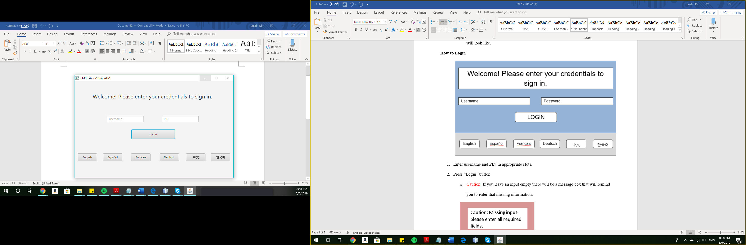

1. Enter username and PIN in appropriate slots.
2. Press “Login” button.
   * Caution: If you leave an input empty there will be a message box that will remind you to enter that missing information.

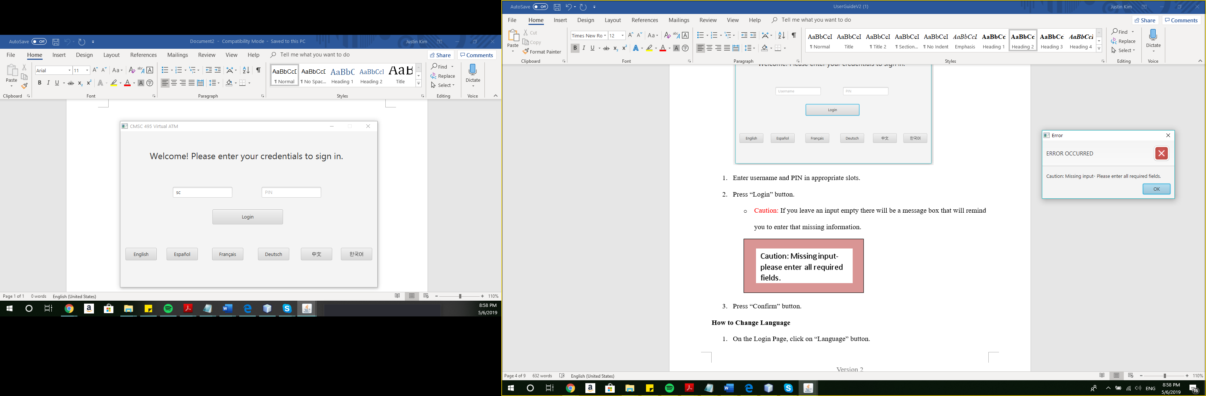

## How to Change Language

1. On the Login Page, click the language you would like the ATM to be in.
2. The ATM will now be in that language.

## Homepage

1. After successfully logging in, the Homepage will display in the language of your choosing.

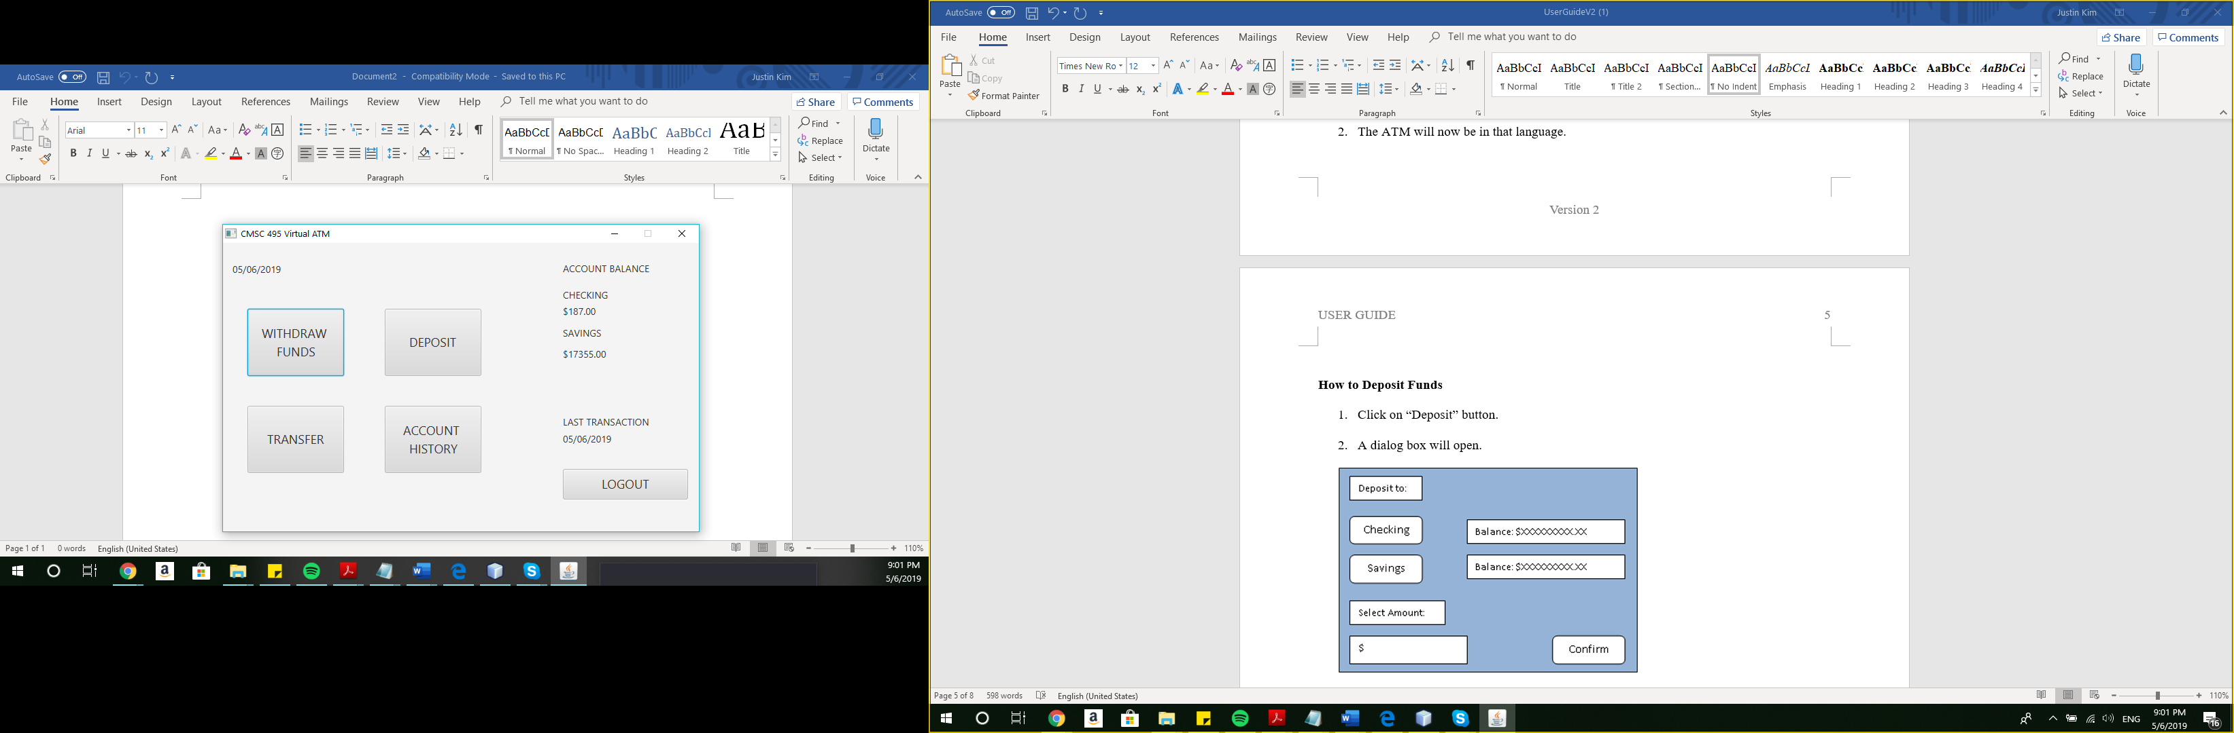

## How to Withdraw Funds

1. Click on “WITHDRAW FUNDS” button.
2. The Withdraw Page will open.

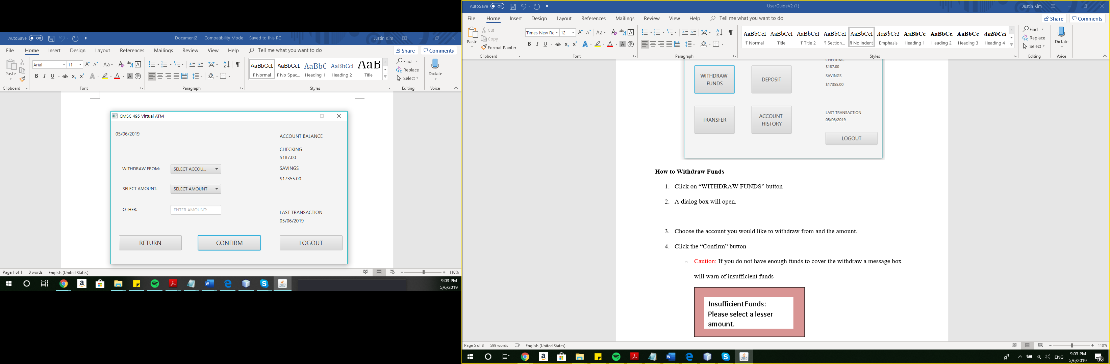

1. Choose the account you would like to withdraw from and the amount.
2. Click the “Confirm” button
   * Caution: If you do not have enough funds to cover the withdraw a message box will warn of insufficient funds

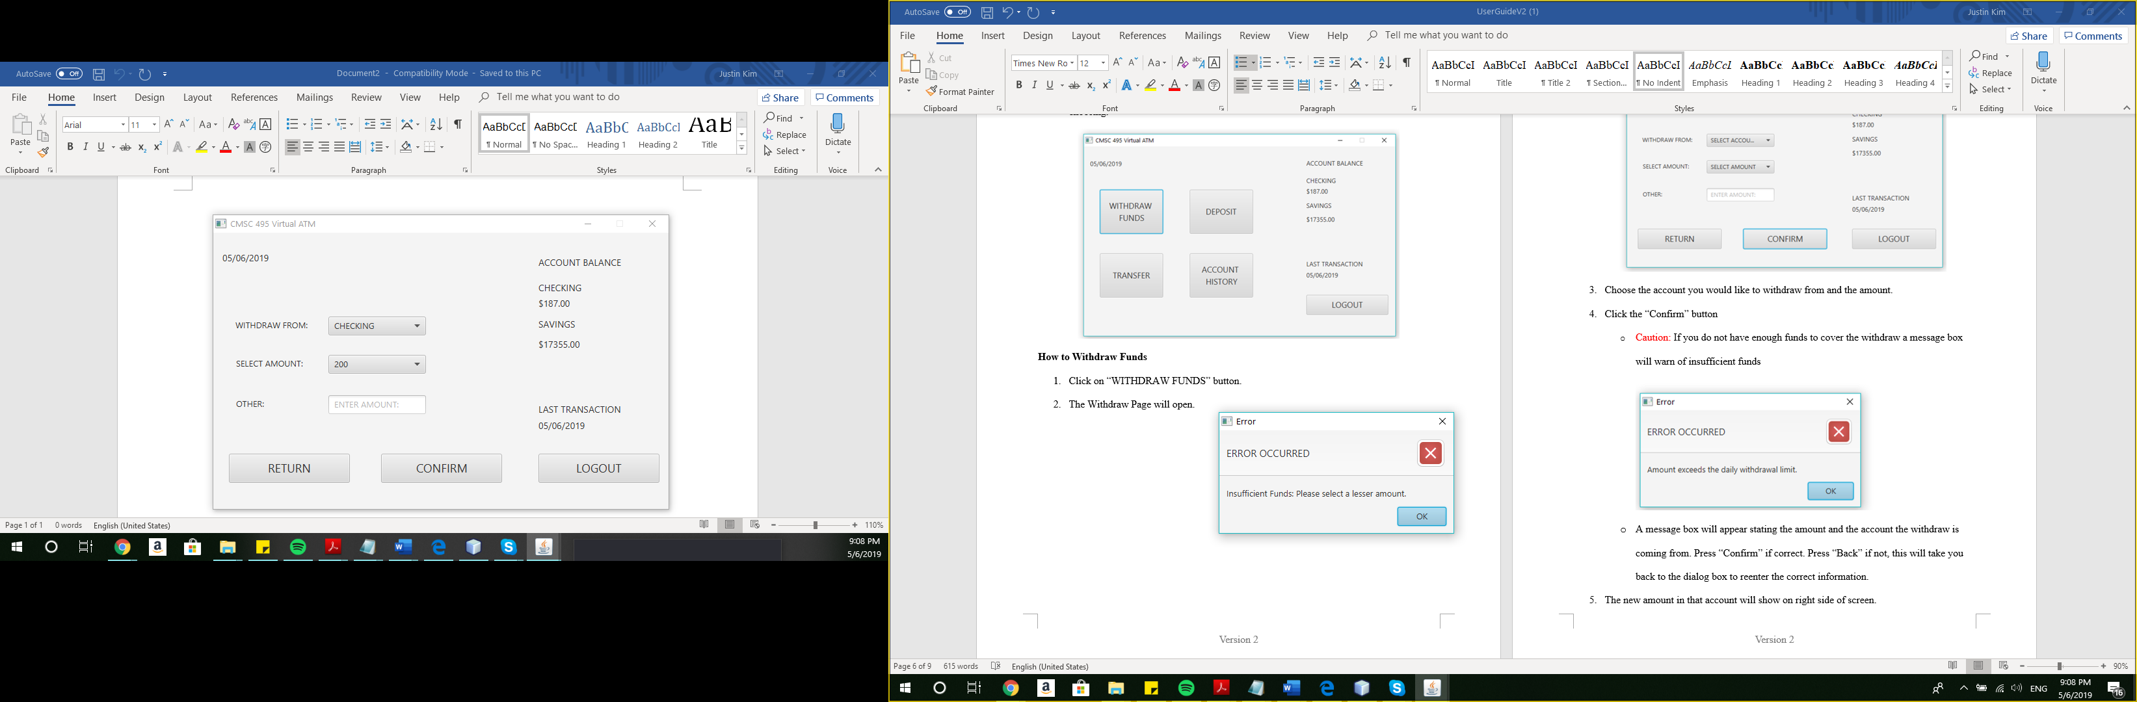

1. The updated account balances will show on right side of screen.
2. If the withdraw limit is exceeded, an error message will pop up.

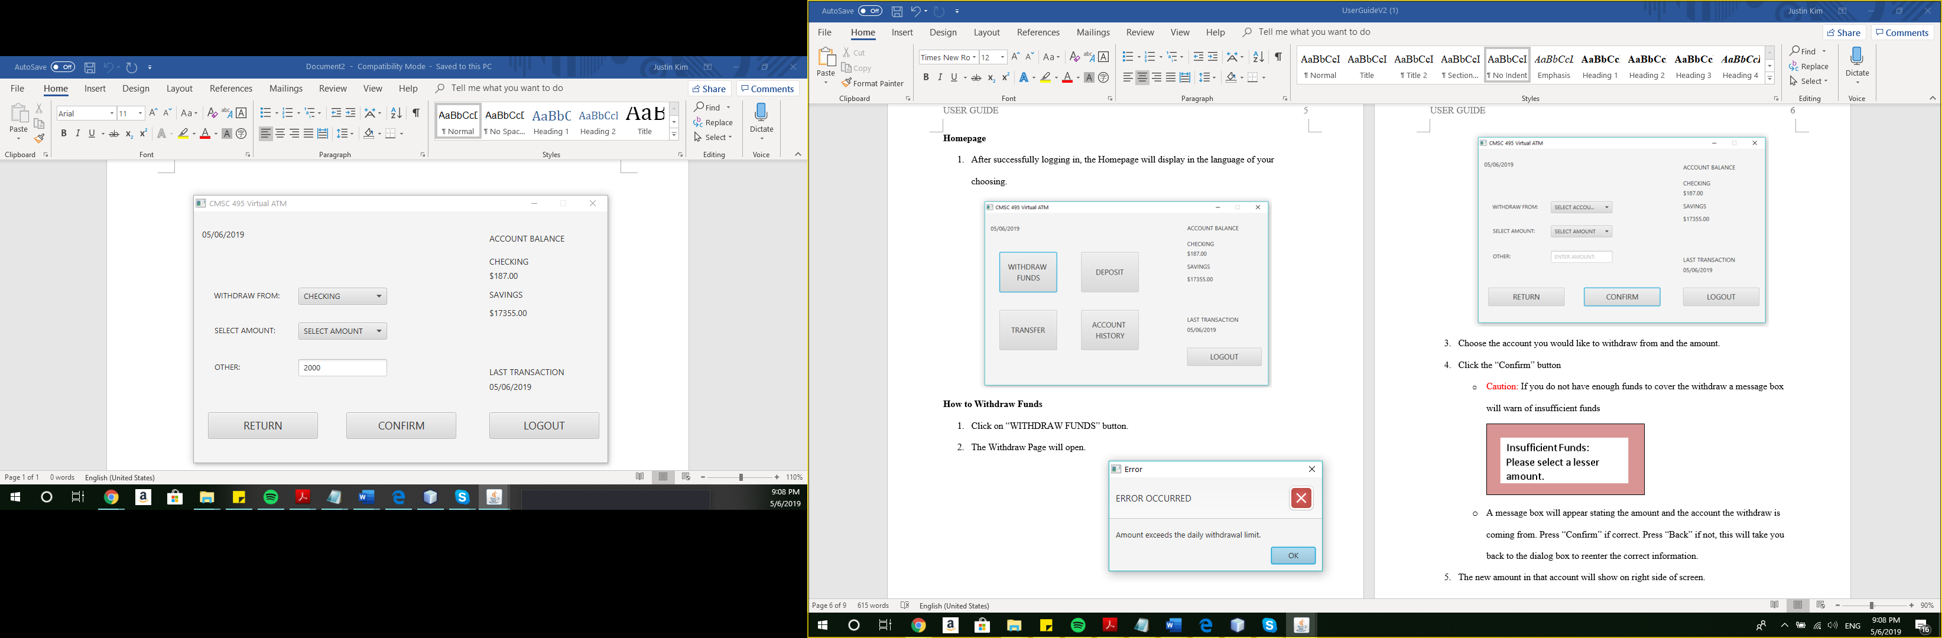

## How to Deposit Funds

1. Click on “Deposit” button.
2. The Deposit Page will open.

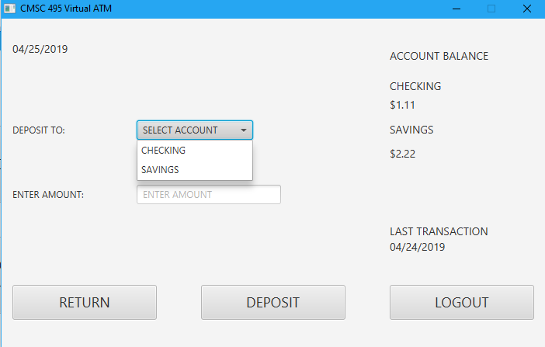

1. Choose the account you would like to deposit to and the amount.
2. Click the “DEPOSIT” button
   * A message box will appear stating whether the transaction was successful or not.
3. The new amount in that account will automatically update on right side of screen.

## How to Transfer Funds

1. Click on “Transfer” button.
2. The Transfer Page will open.

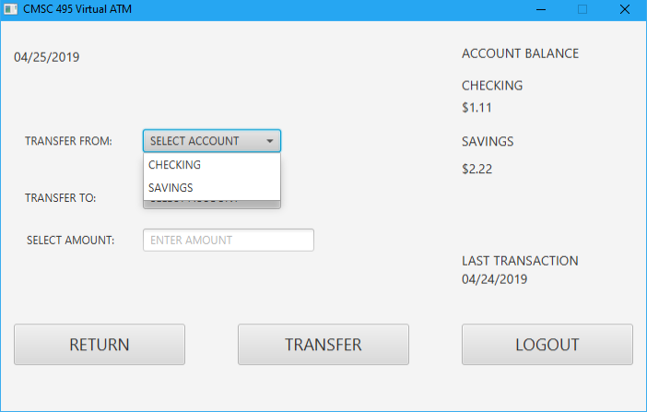

1. Choose the account you would like to transfer to and from.
2. Choose the amount you would like to transfer.
   * Caution: If there are not enough funds for transfer a message box will warn of insufficient funds
   * A message box will appear stating whether the transaction was successful or not.
3. The new amount in that account will automatically update on right side of screen.

## How to Check the Balance of an Account

1. Account balances are shown on the right side of all pages.

## How to Check Account History

1. Click on “Account History” button.
2. The Account History Page will open.
3. A scrollable message box will show the history of all transactions.

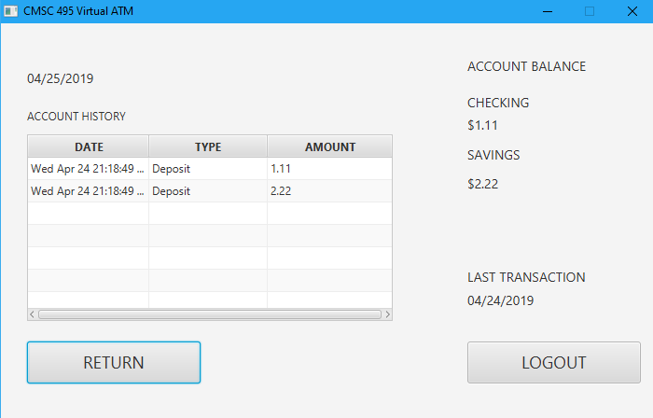

## How to Logout

1. Click on “Logout” button.
2. The program will return to the Login Page
   * “RETURN” will bring you back to the Main Menu
   * “LOGOUT” will logout of the account and return to the Login Page.

# Test Plan and Results

|  |  |  |  |  |
| --- | --- | --- | --- | --- |
| Test Case | Input | Expected Output | Actual Output | Result |
| 1. No Username provided | Empty username | Message box requesting all required fields | Message box requesting all required fields | Pass |
| 2. No password provided | Empty PIN | Message box requesting all required fields | Message box requesting all required fields | Pass |
| 3. Login with wrong username and password combination | XML file  Wrong username and password combination | Message box requesting a valid account | Message box requesting a valid account | Pass |
| 4. Non-numeric account balance on checking account | XML file | Account Balance on checking Account will be 0 | Account Balance on checking Account is 0 | Pass |
| 5. Non-numeric account balance on savings account | XML file | Account Balance on Savings Account will be 0 | Account Balance on Savings Account is 0 | Pass |
| 6. Username and PIN wrong 3 times | GUI input | Message box stating login failed. Return to Login page. Account locked. | Message box stating login failed. Return to Login page. Account locked. | Pass |
| 7. Transfer $100.01 from checking to savings | GUI input  XML file | Checking account balance decrements by $100.01  Savings account increases by $100.01  XML file updated correctly | Checking account balance decrements by $100.01  Savings account increases by $100.01  XML file updated correctly | Pass |
| 8. Transfer $100.01 from savings to checking | GUI input  XML file | Savings account balance decrements by $100.01  Checking account increases by $100.01  XML file undated correctly | Savings account balance decrements by $100.01  Checking account increases by $100.01  XML file undated correctly | Pass |
| 9. Withdraw $100 from checking | GUI input  XML file | Checking account balance decrements by $100  XML file updated correctly | Checking account balance decrements by $100  XML file updated correctly | Pass |
| 10. Withdraw $100 from savings | GUI input  XML file | Savings account balance decrements by $100  XML file updated correctly | Savings account balance decrements by $100  XML file updated correctly | Pass |
| 11. Transfer attempt from Checking to Savings account with insufficient balance in Checking | GUI input | Message box stating transfer aborted because of insufficient balance | Message box stating transfer aborted because of insufficient balance | Pass |
| 12. Transfer attempt from Savings to Checking account with insufficient balance in Savings | GUI input | Message box stating transfer aborted because of insufficient balance | Message box stating transfer aborted because of insufficient balance | Pass |
| 13. Withdrawal attempt from Savings account with insufficient balance in Savings | GUI input | Message box stating withdrawal aborted because of insufficient balance | Message box stating withdrawal aborted because of insufficient balance | Pass |
| 14. Withdrawal attempt from Checking account with insufficient balance in Checking | GUI input | Message box stating withdrawal aborted because of insufficient balance | Message box stating withdrawal aborted because of insufficient balance | Pass |
| 15. Deposit $100.01 to Checking | GUI input  XML file | Checking account balance increments by $100.01  XML file updated correctly  Main page refreshes account balance | Checking account balance increments by $100.01  XML file updated correctly  Main page refreshes account balance | Pass |
| 16. Deposit $100.01 to Savings | GUI input  XML file | Savings account balance increments by $100.01  XML file updated correctly  Main page refreshes account balance | Savings account balance increments by $100.01  XML file updated correctly  Main page refreshes account balance | Pass |
| 18. An attempt to withdraw  $-20 | GUI input | Message box alerting customer to enter a positive amount | Message box alerting customer to enter a positive amount | Pass |
| 19. An attempt to deposit $-20 | GUI input | Message box alerting customer to enter a positive amount | Message box alerting customer to enter a positive amount | Pass |
| 20. Attempt to withdraw $601 in a single transaction | GUI input | Message box alerting customer that the transaction exceeds the daily withdrawal limit | Message box alerting customer that the transaction exceeds the daily withdrawal limit | Pass |
| 21. Perform two $200 and one $200.01 withdrawal to exceed daily limit | GUI Input | Message box alerting customer on the last transaction that the daily withdrawal limit has been exceeded. | Message box alerting customer on the last transaction that the daily withdrawal limit has been exceeded. | Pass |
| 22. All tests will be duplicated with each language used | GUI input  XML file | All languages are translated correctly. | All languages are translated correctly. | Pass |

Test Case 1: No username provided

English

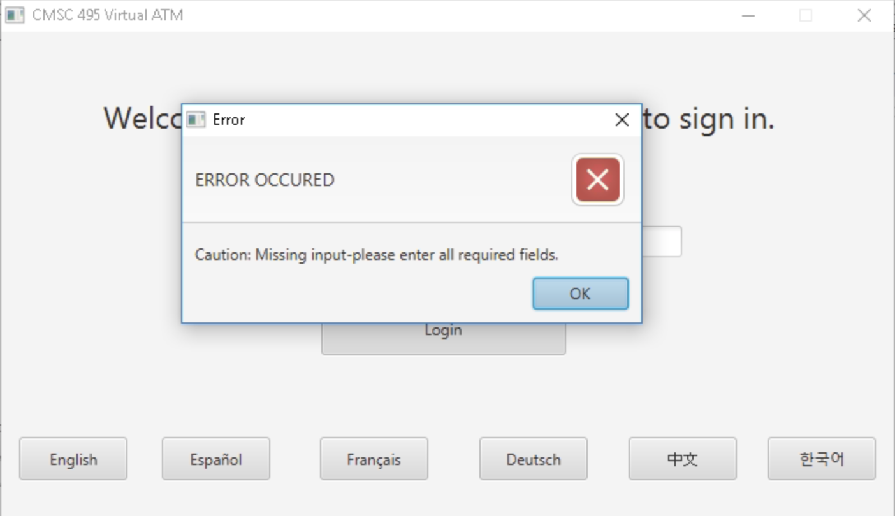

French

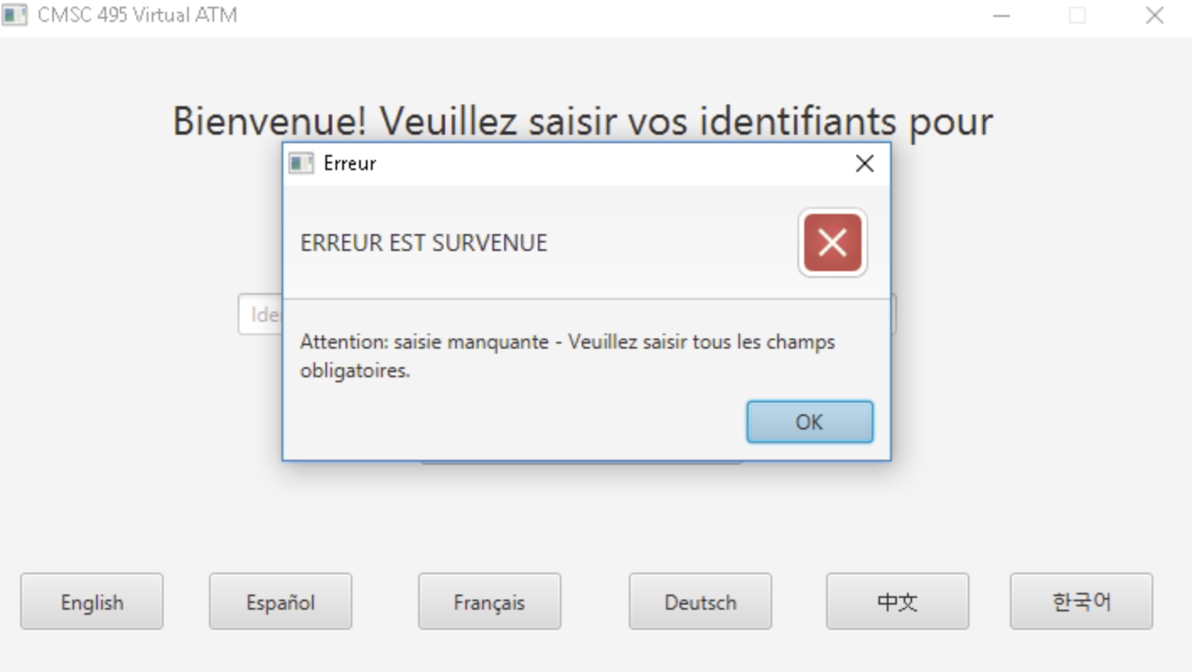

German

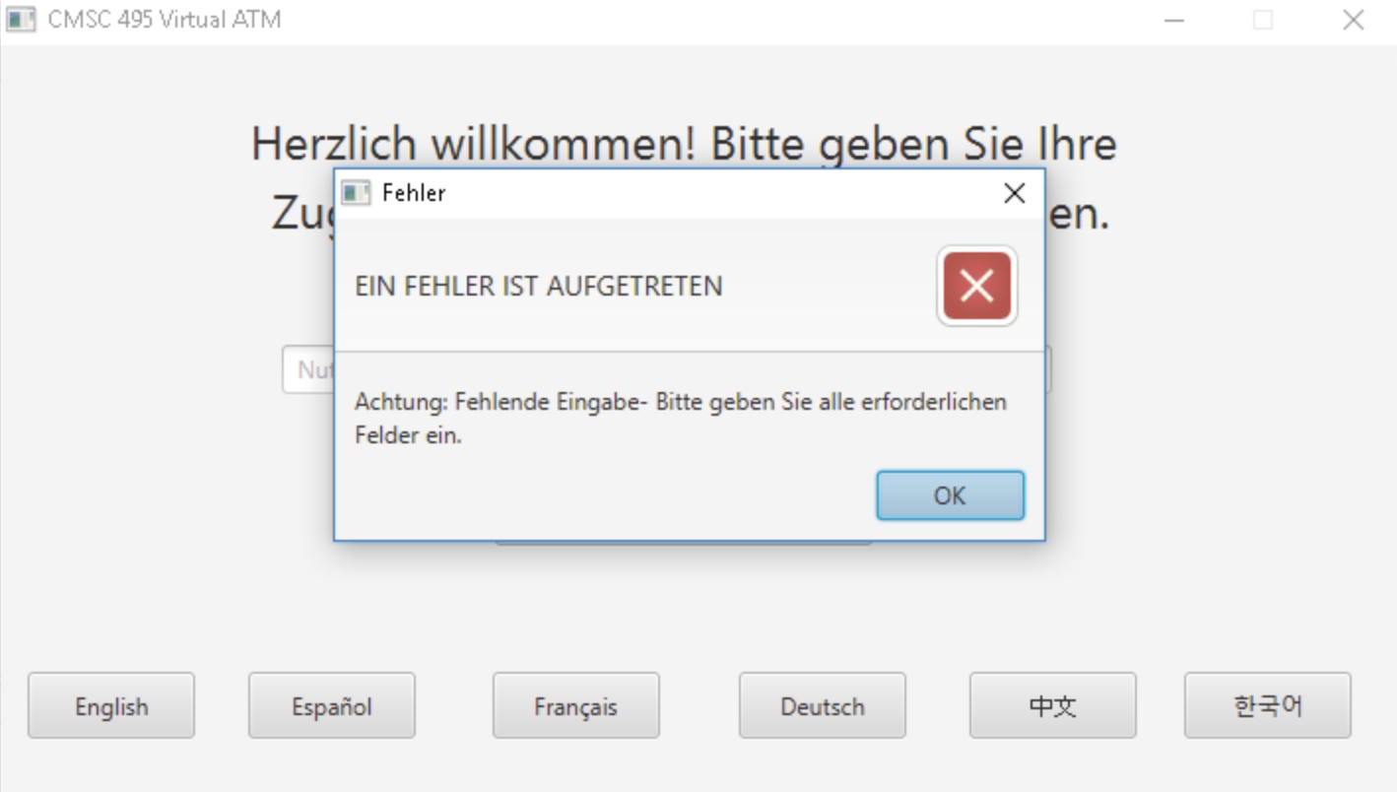

Chinese

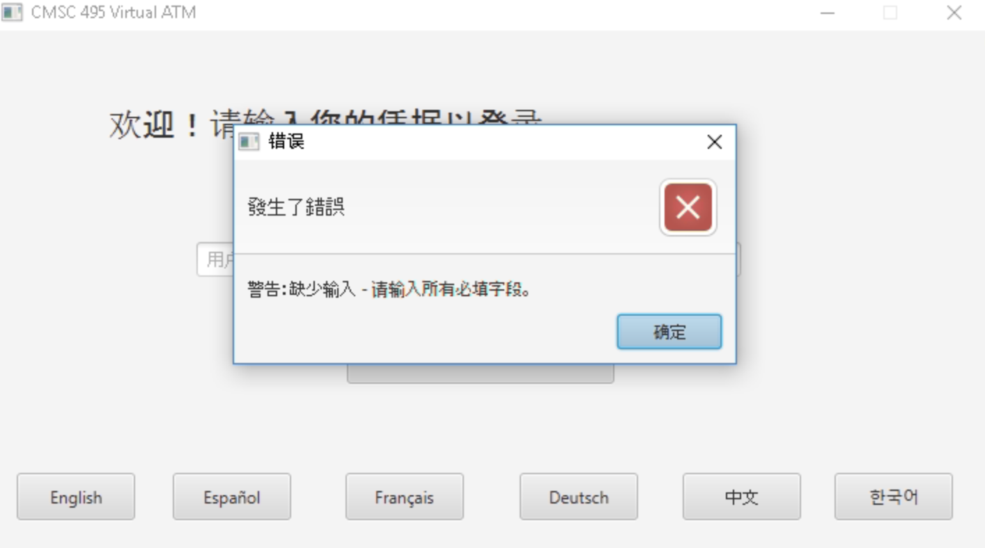

Spanish

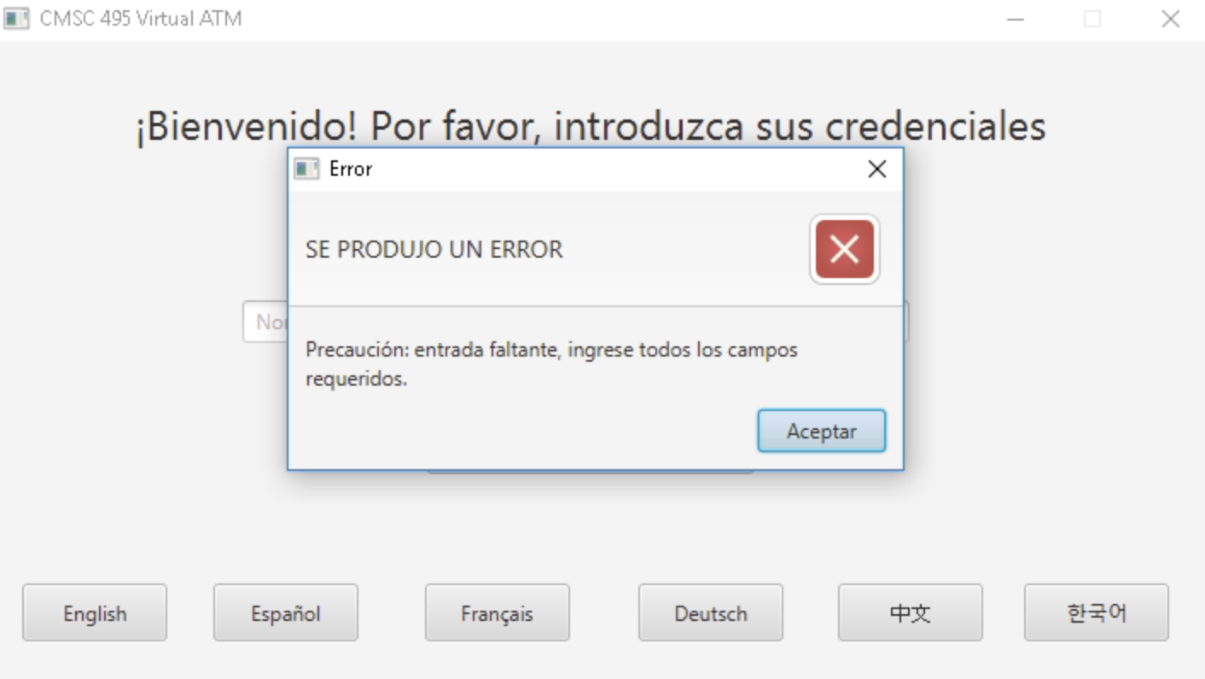

Korean

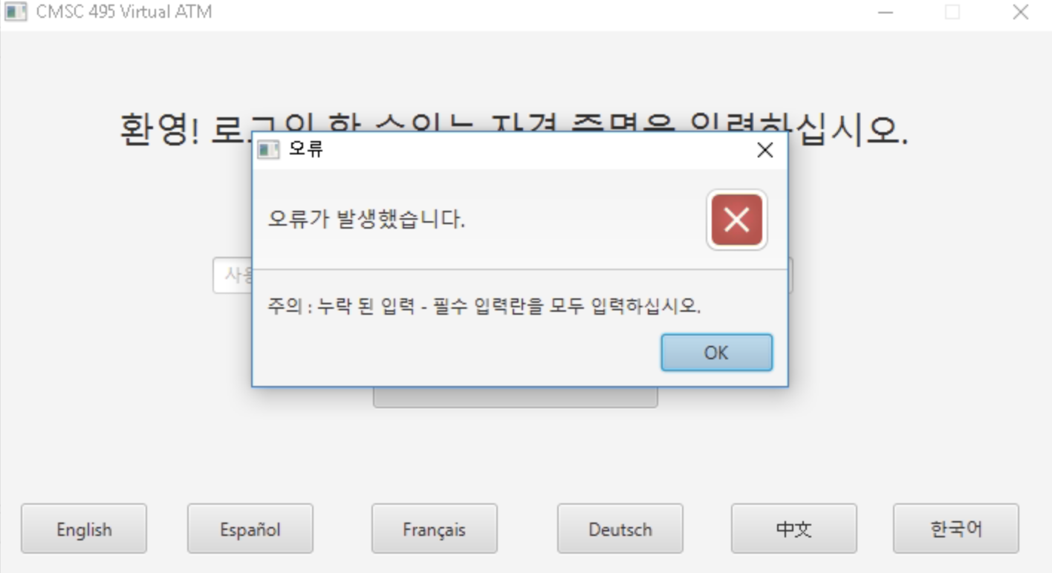

Test Case 2: No password provided

English

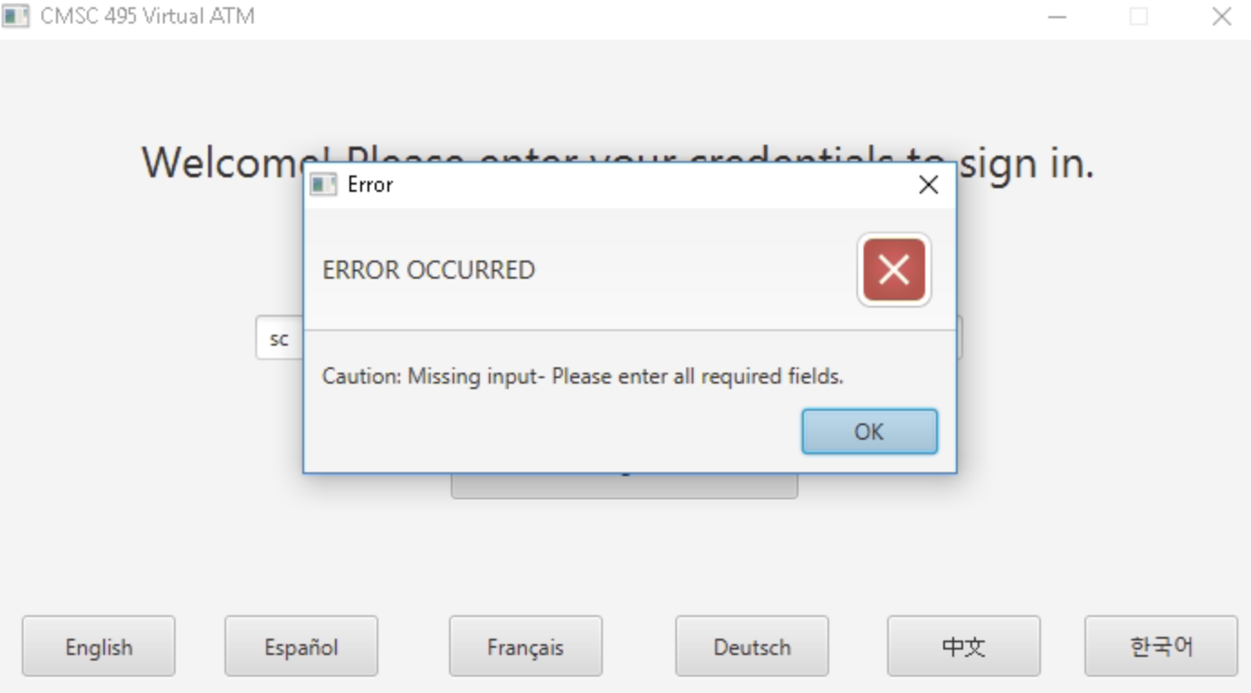

French

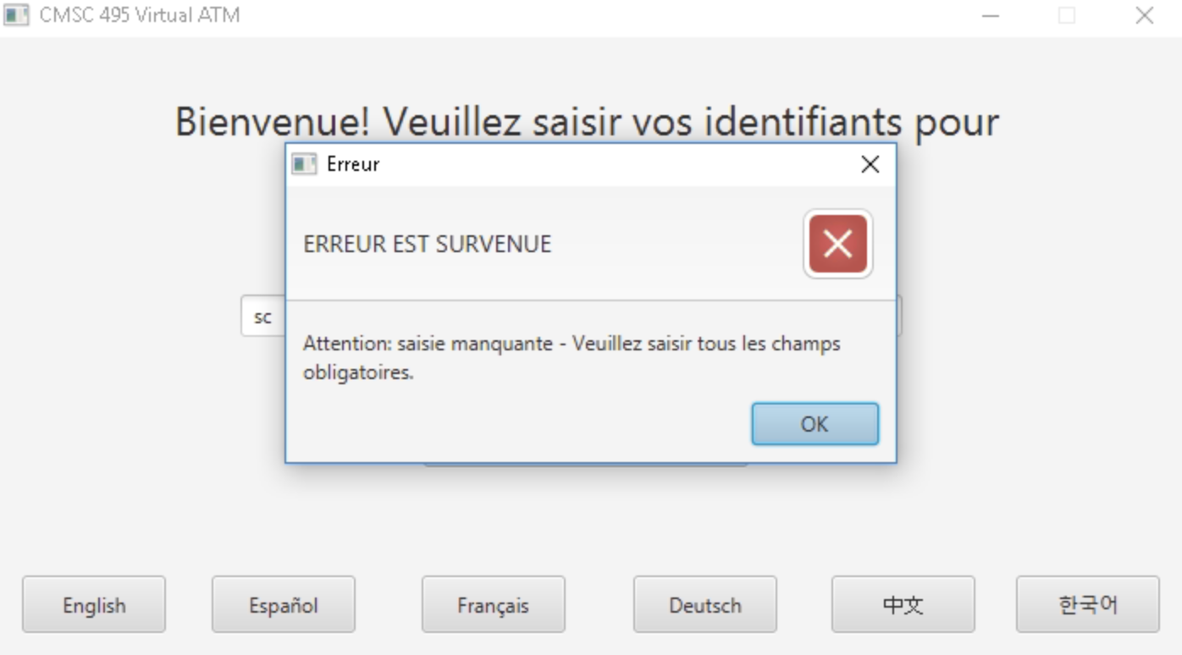

German

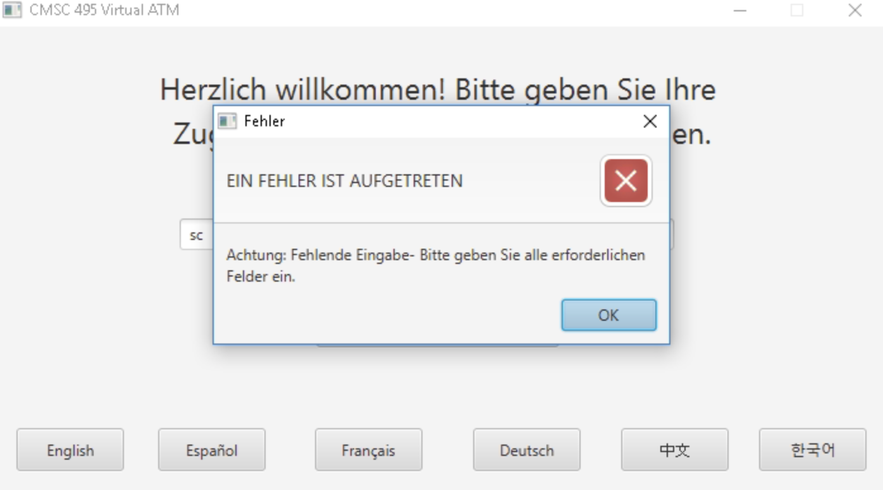

Chinese

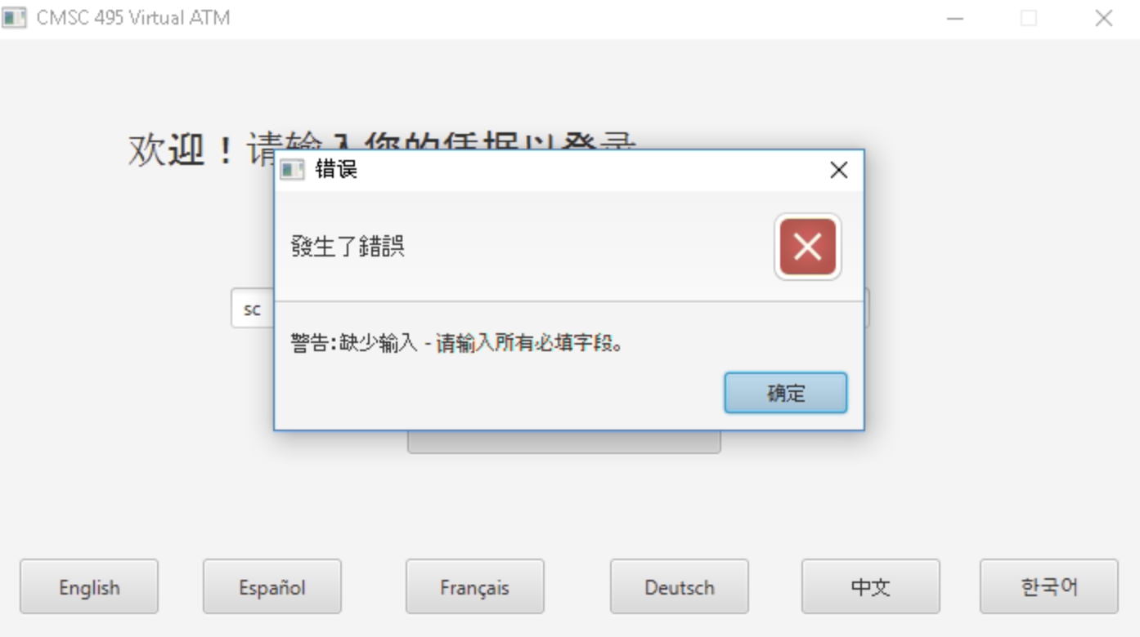

Spanish

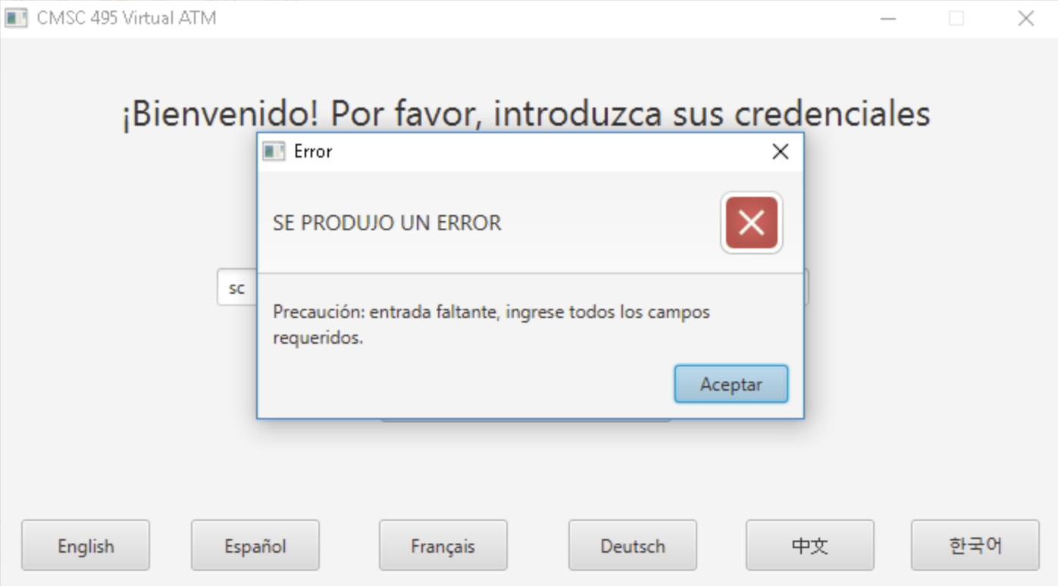

Korean

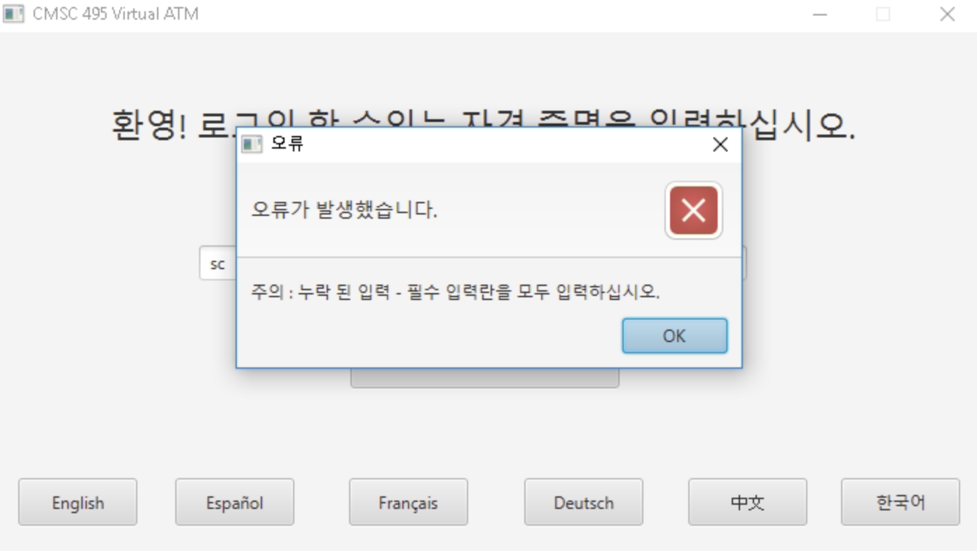

Test Case 3: Login with wrong username and password combination

English

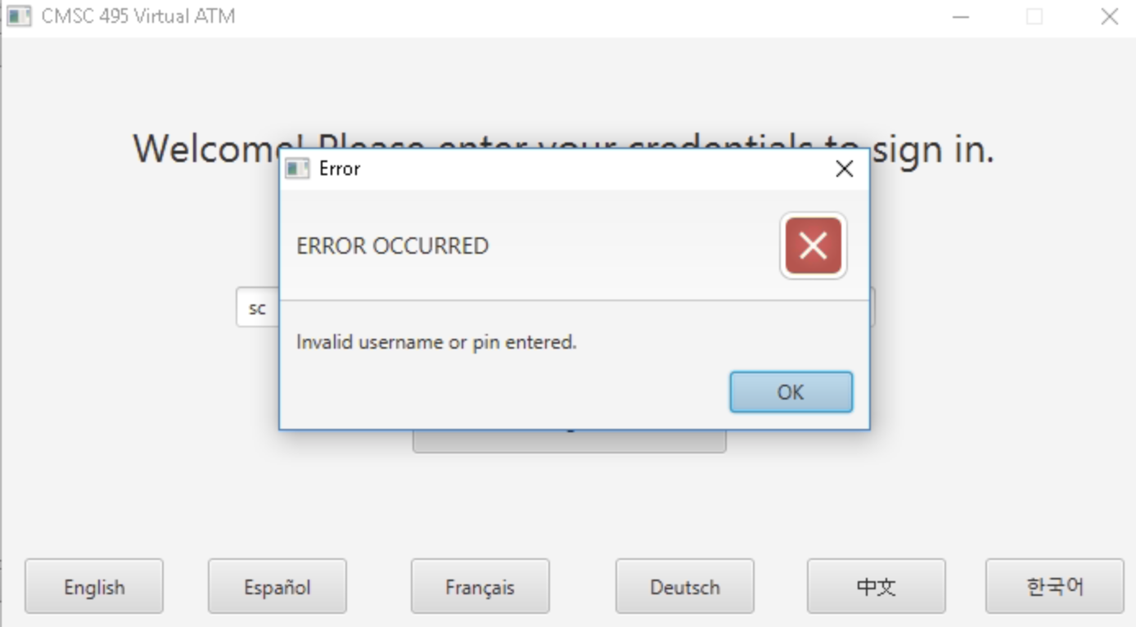

French

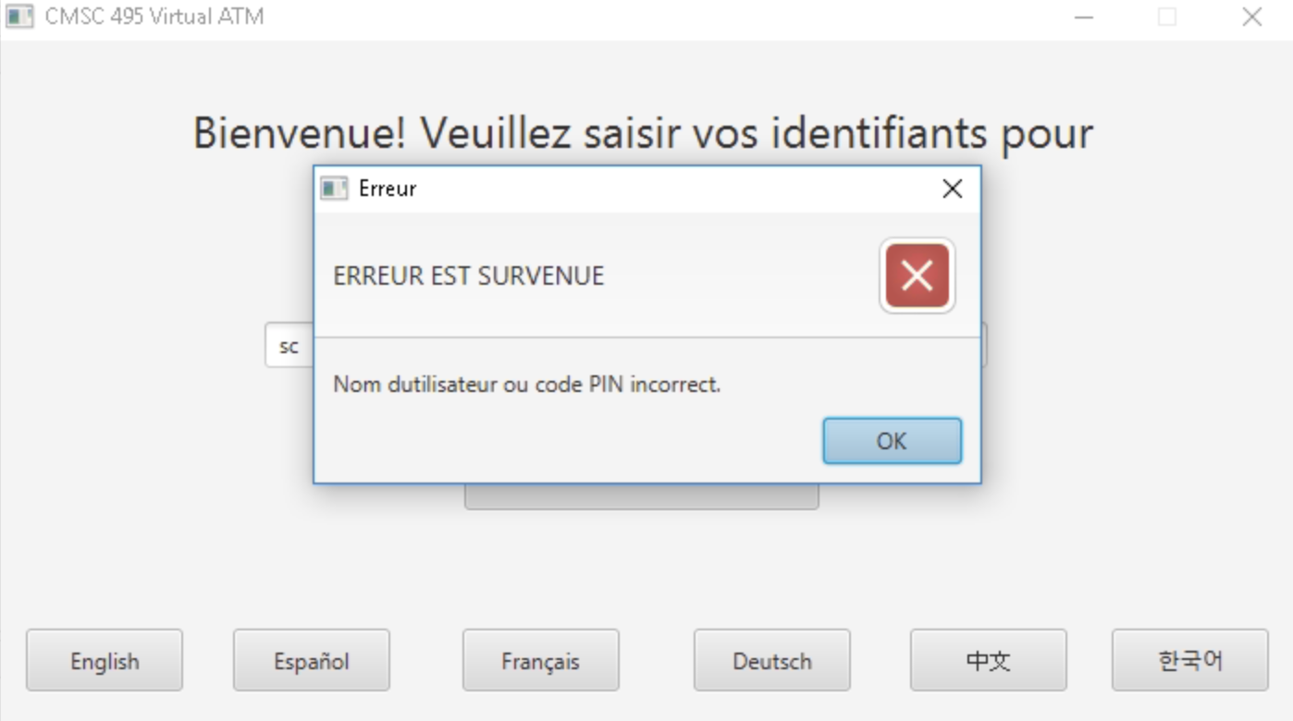

German

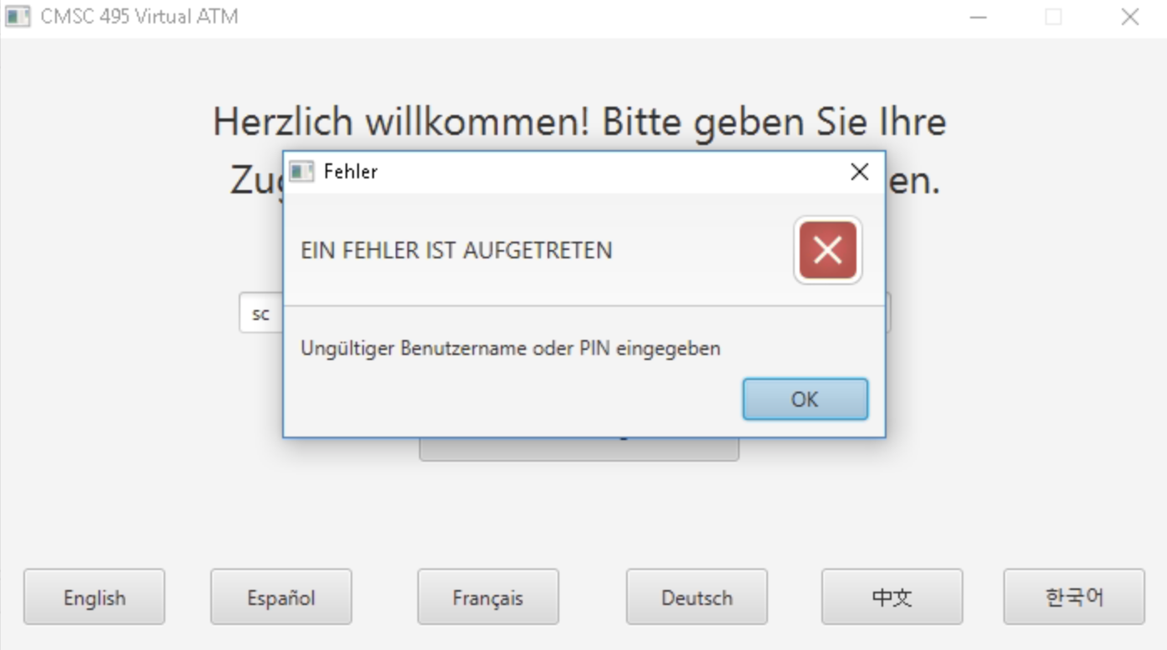

Chinese

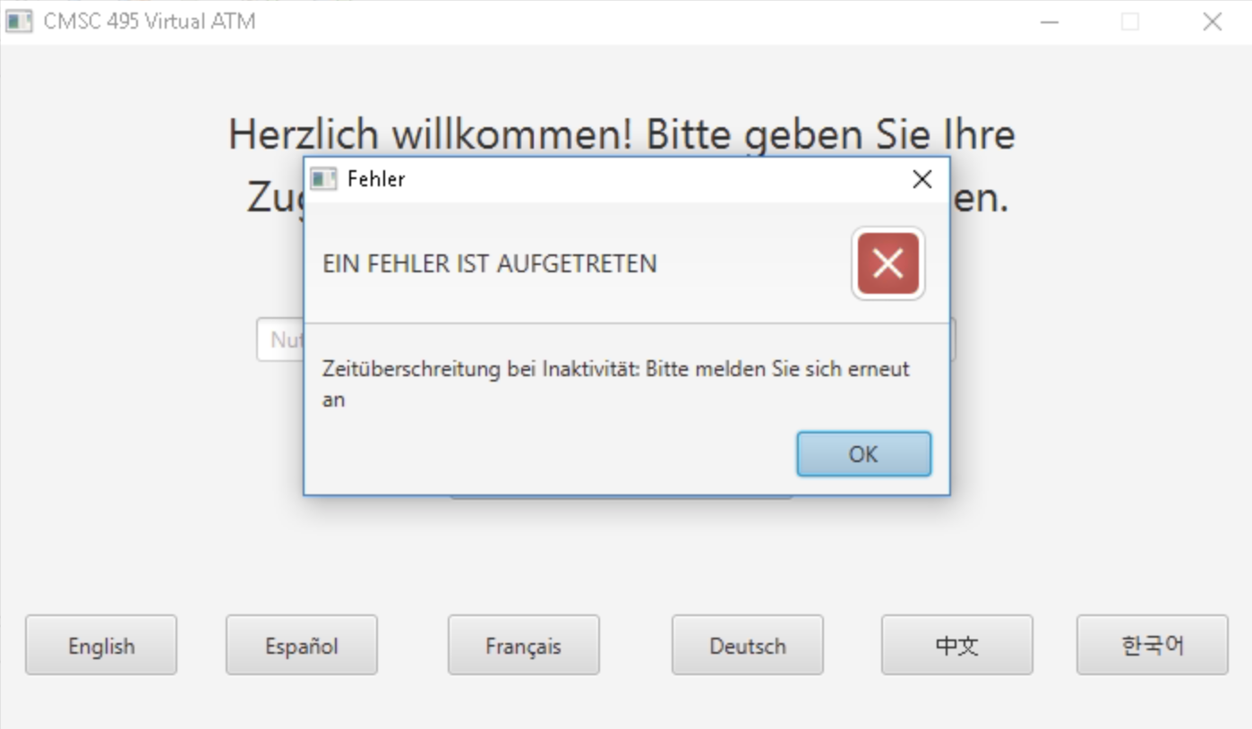

Spanish

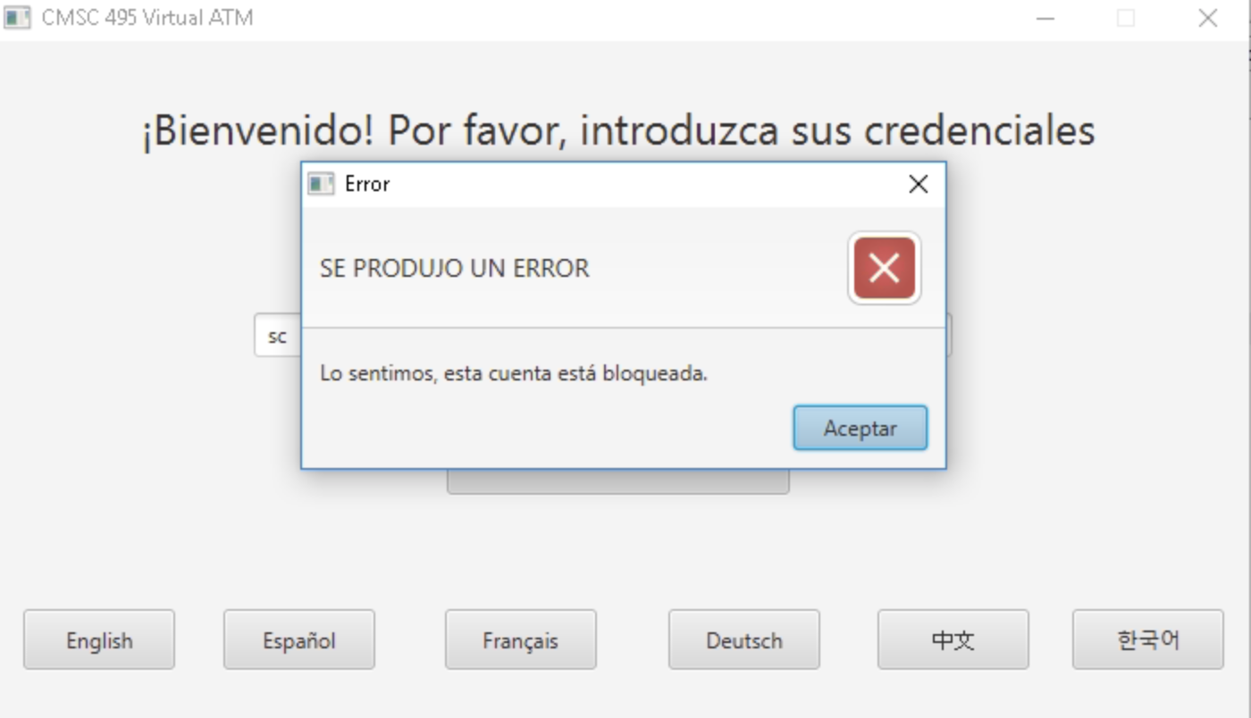

Korean

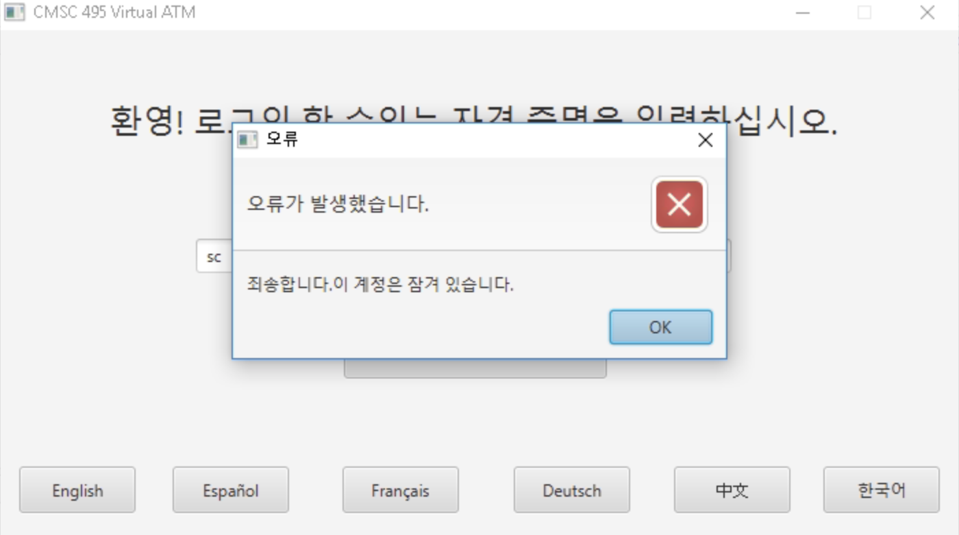

Test Case 4: Non-numeric account balance on checking account

English

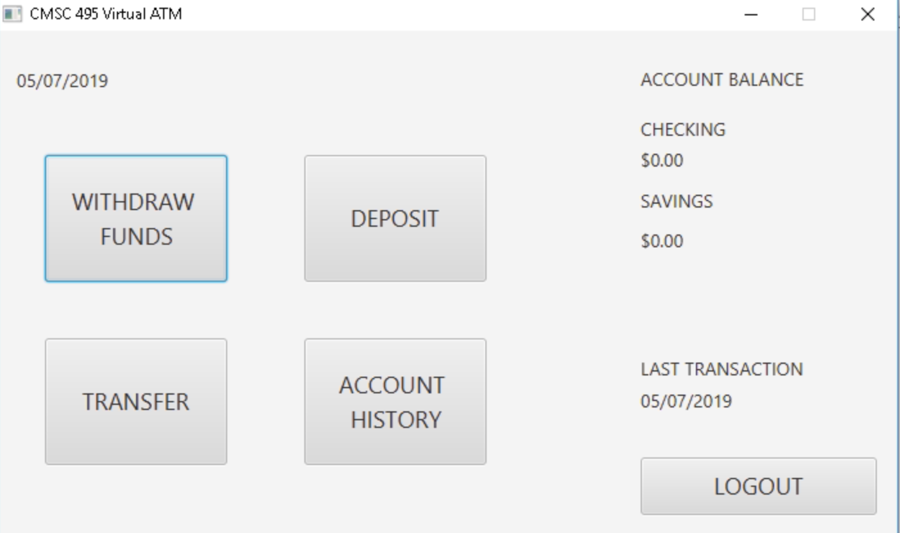

French

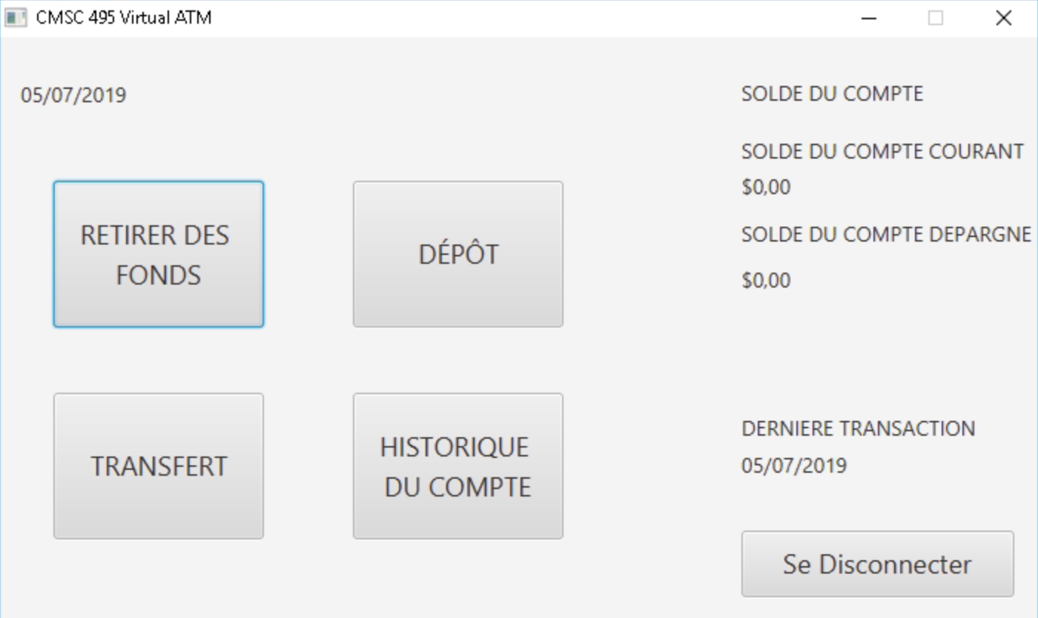

German

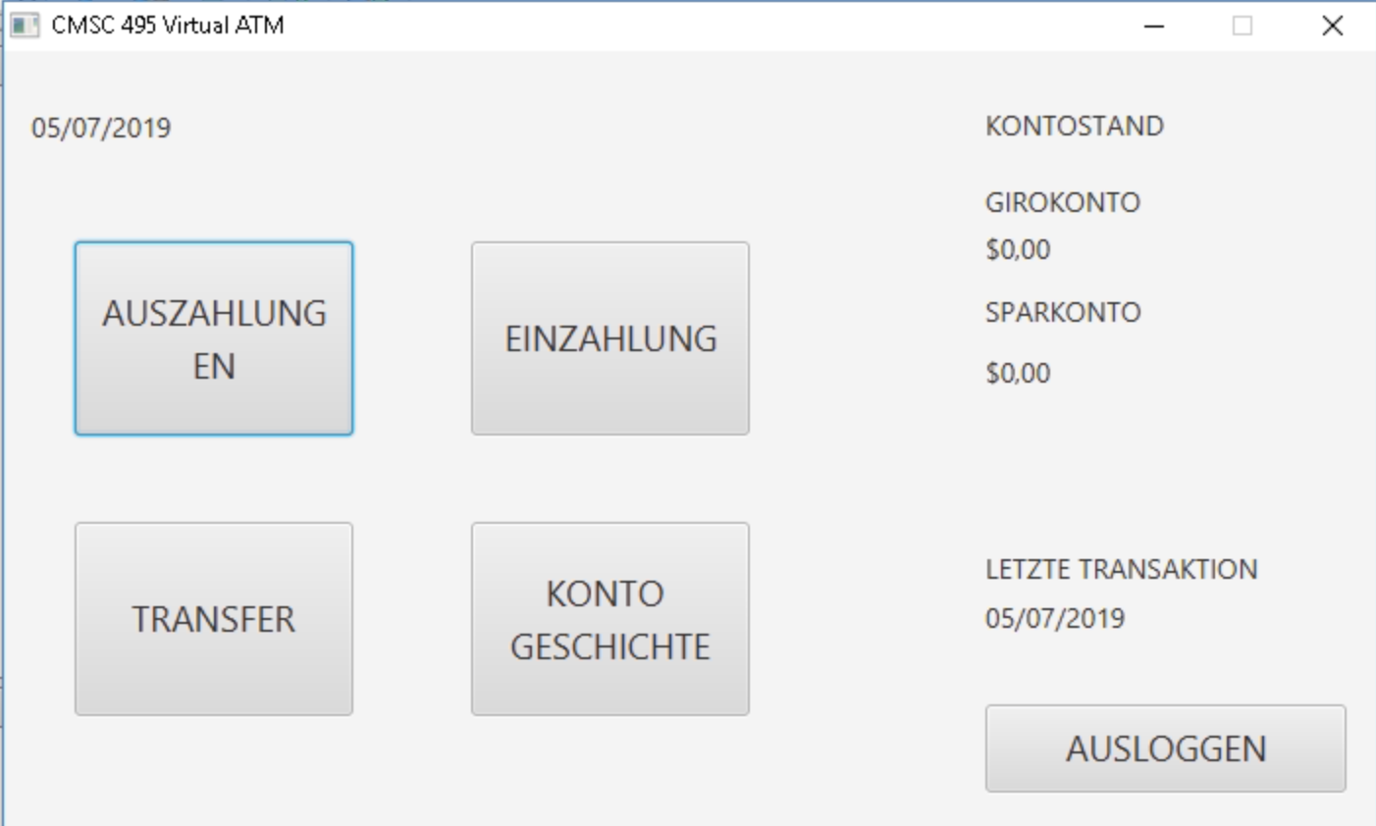

Chinese

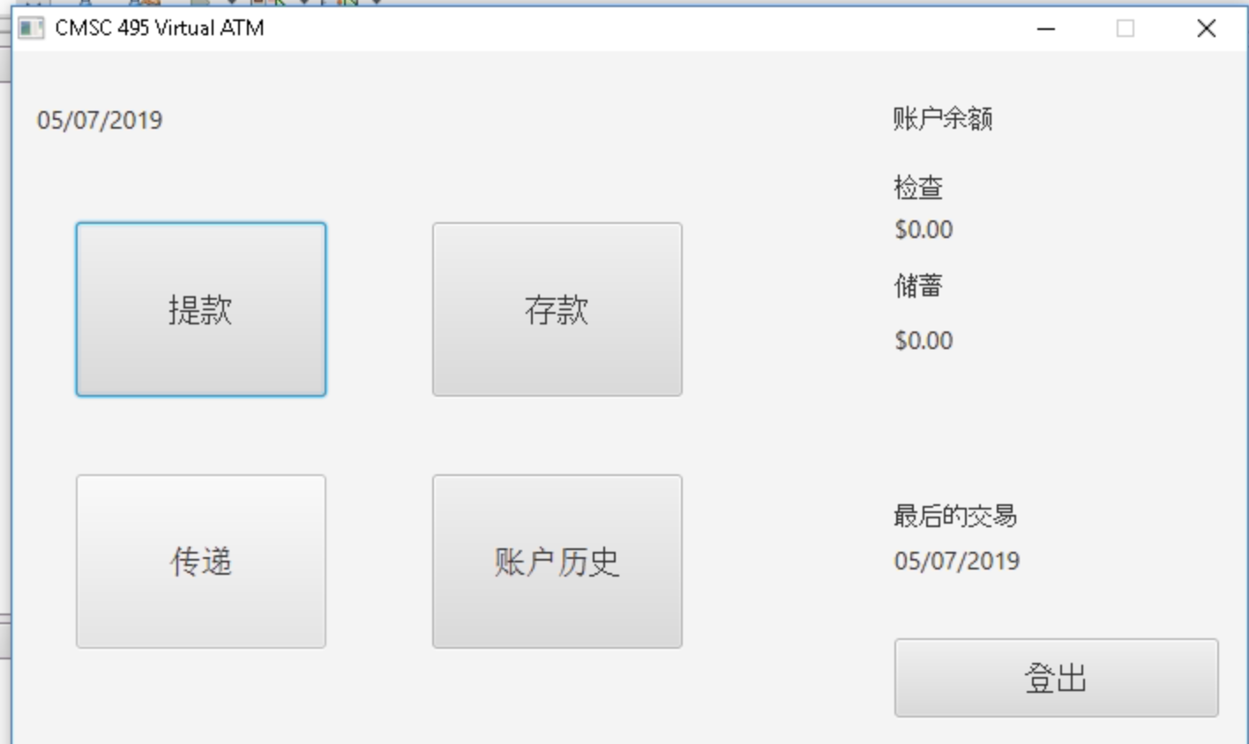

Spanish

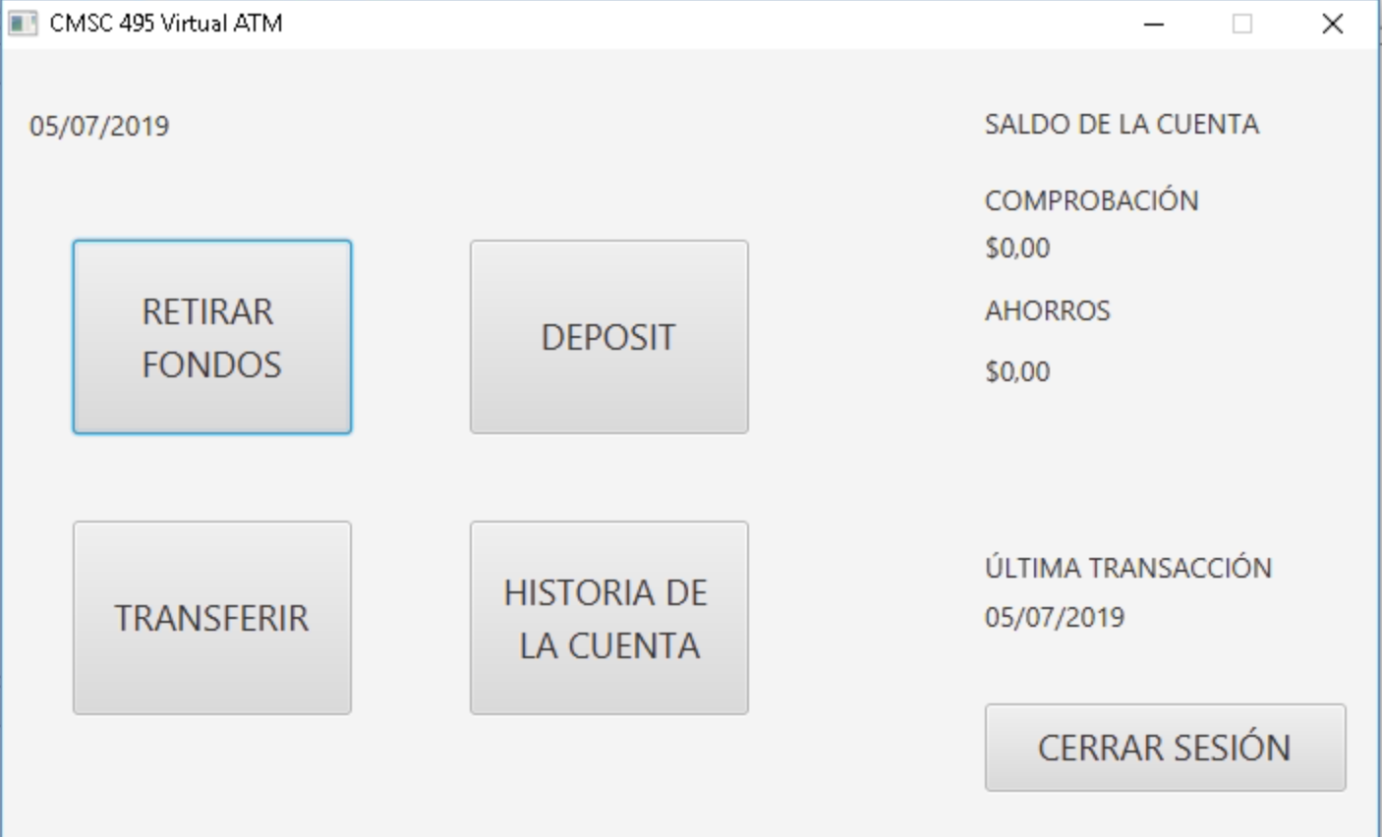

Korean

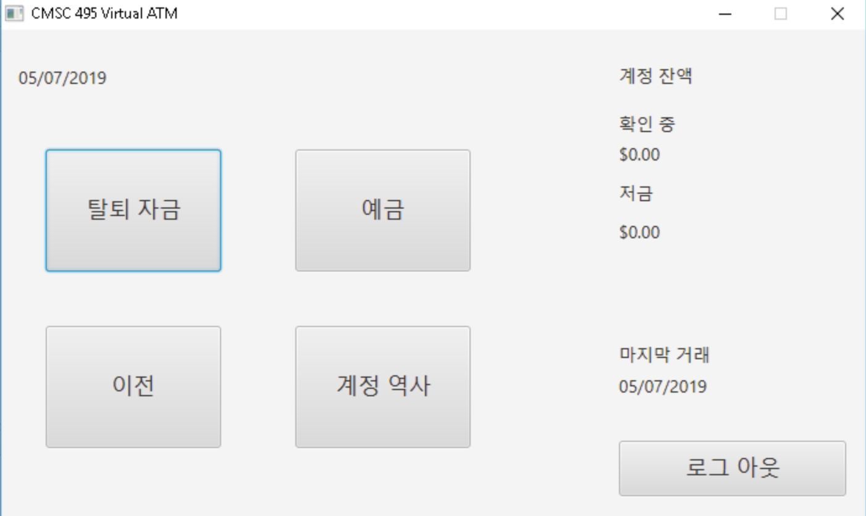

Test Case 5: Non-numeric account balance on savings account

English

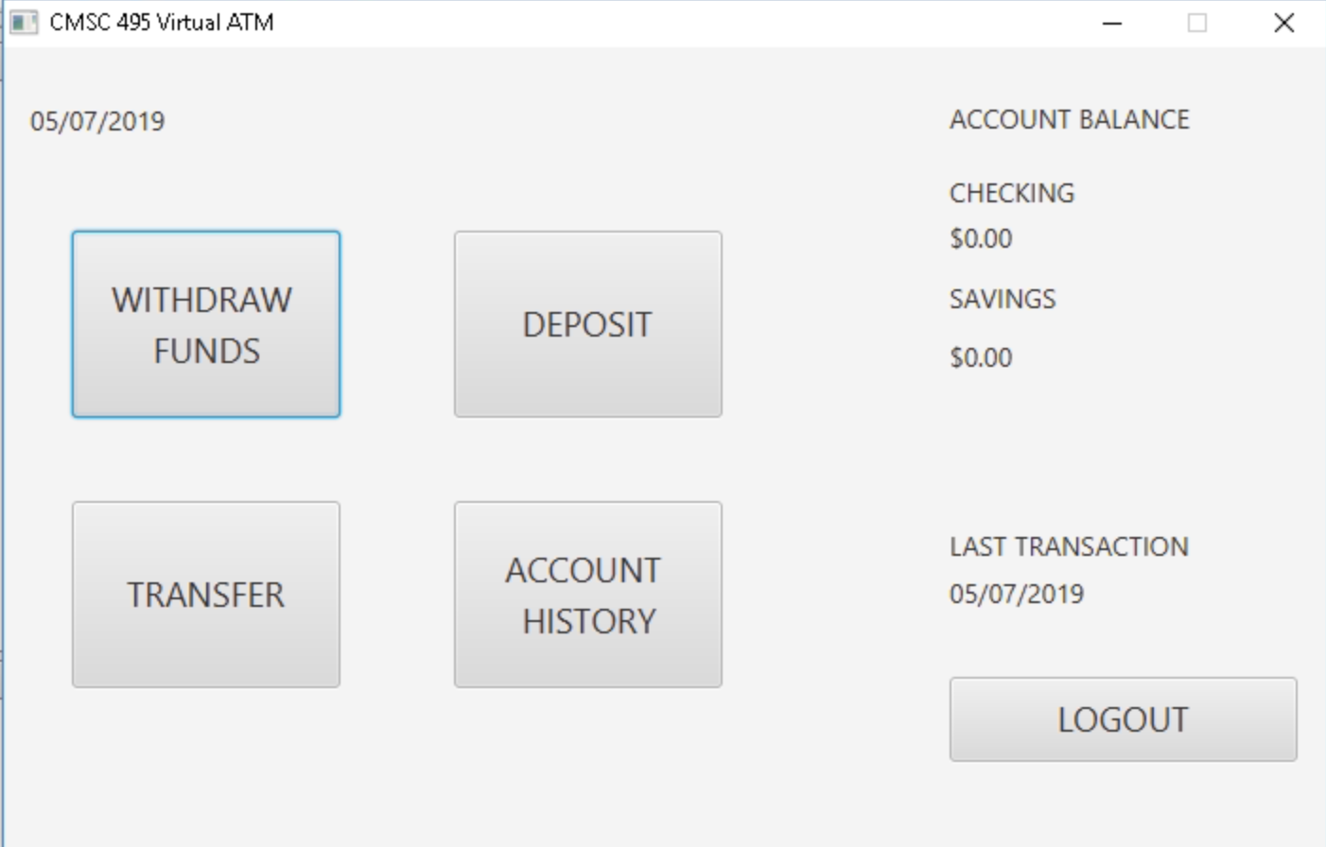

French



German



Chinese



Spanish



Korean



## Test Result Screenshots

# Design and Alternate Designs

## Design Summary

This ATM machine project is intended to simulate basic operations that a user would perform on a real ATM machine. As stated in the project plan, our ATM project will be a java-based application and the user interface will be developed using JavaFX.

The following diagram represents a high-level overview of the layered application design approach we will use to implement this project.

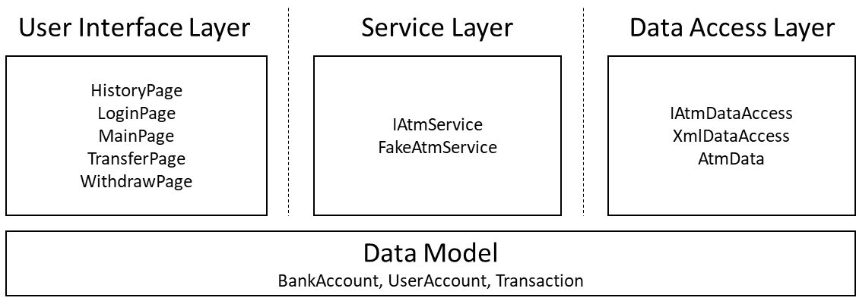

Figure 1. Application Architecture Overview

## Data Structures and Data Types

As shown above, the data model used to represent information in our application consists of three basic data structures:

* UserAccount
* BankAccount
* Transaction

In addition to the above data structures, several other Java data types will be used throughout the project:

* String
* Boolean
* long
* double
* int
* Date

## Input and Output Formats

In this project, user input will be essentially collected from JavaFX TextFields and Buttons. Output will be typically be displayed on JavaFX TextFieldAreas, Labels, and/or DialogBoxes.

## Classes, Methods, Fields, Interfaces, FXML

|  |  |  |
| --- | --- | --- |
| **Files** | **Purpose** | **Attributes/Methods** |
| VirtualAtm.java | JavaFX application entry point | **Methods**  Start()  Main() |
| BaseAtmController.java | Base class from which all UI controllers will derive. Will contain helper methods and references to facilitate navigation, atm service access, language translation. | **Attributes**  ResourceBundle resources  URL location  IAtmService atmService  ObjectProperty<Locale> locale  IAtmService atmService  Stage primaryStage  **Methods**  void initialize(URL url, ResourceBundle rb)  IAtmService getAtmService()  void showMainPage()  void showLoginPage()  void showDepositPage()  void showHistoryPage()  void showTransferPage()  void showWithdrawPage()  void setStage(Stage stage)  void showPage(String fxmlPath)  showError(String message)  void setLanguageId(String langId, String country)  String getTranslatedText(final String key, final Object... args)  StringBinding createTranslatedTextBinding(final String key, Object... args)  showError(String message) |
| DepositPage.fxml | Holds layout and control information for the Deposit Page | N/A |
| DepositPageController.java | The “controller” for the deposit page. Contains method which validate user input for making a deposit and trigger the operation on the atm service layer. | **Atributes**  Label topLabel  Label checkingAmountLabel  Label savingsAmountLabel  Label lastTransactionDateLabel  TextField depositAmount  String selectedAccountType  ComboBox<String> fromAccount  **Methods**  void initialize(URL url, ResourceBundle rb)  void refresh()  void handleDepositAccountType(ActionEvent event)  void handleDepositAction(ActionEvent event)  void handleLogoutAction(ActionEvent event)  boolean validateUserInput()  double parseDepositAmount(String text)  void handleReturnAction(ActionEvent event) |
| HistoryPage.fxml | Holds layout and control information for the History Page | N/A |
| HistoryPageController.java | The “controller” for the history page. Contains methods which will allow the user to logout of the application or return to the main page. | **Attributes**  Label topLabel  Label checkingAmountLabel  Label savingsAmountLabel  Label lastTransactionDateLabel  TableView<Transaction> historyTableView  TableColumn<Transaction, Date> dateColumn  TableColumn<Transaction, String> typeColumn  TableColumn<Transaction, Double> amountColumn  **Methods**  void initialize(URL url, ResourceBundle rb)  void handleLogoutAction(ActionEvent event)  void handleReturnAction(ActionEvent event)  void refresh() |
| LoginPage.fxml | Holds layout and control information for the Login Page | N/A |
| LoginPageController.java | The “controller” for the login page. Contains methods which validate user input for logging into the application and changing languages. | **Attributes**  Label welcomeText  TextField userName  PasswordField userPin  Button loginButton  **Methods**  void initialize(URL url, ResourceBundle rb)  void handleLoginAction(ActionEvent event)  void handleDeutschAction(ActionEvent event)  void handleEnglishAction(ActionEvent event)  void handleFrenchAction(ActionEvent event)  void handleKoreanAction(ActionEvent event)  void handleLoginAction(ActionEvent event)  void handleSimplifiedChineseAction(ActionEvent event)  void handleSpanishAction(ActionEvent event)  boolean validateUserInput() |
| MainPage.fxml | Holds layout and control information for the Login Page | N/A |
| MainPageController.java | The “controller” for the main page. Contains methods which allow the user to display the account history, deposit, transfer, and withdraw pages. | **Attributes**  Label topLabel  Label checkingAmountLabel  Label savingsAmountLabel  Label lastTransactionDateLabel  **Methods**  void initialize(URL url, ResourceBundle rb)  void handleAccountHistoryAction(ActionEvent event)  void handleDepositAction(ActionEvent event)  void handleLogoutAction(ActionEvent event)  void handleTransferAction(ActionEvent event)  void handleWithdrawAction(ActionEvent event) |
| TransferPage.fxml | Holds layout and control information for the Login Page | N/A |
| TransferPageController.java | The “controller” for the deposit page. Contains method which validate user input for making a tran and trigger the operation on the atm service layer. | **Attributes**  Label topLabel  Label checkingAmountLabel  Label savingsAmountLabel  Label lastTransactionDateLabel  TextField transferAmount  ComboBox<String> fromAccount  ComboBox<String> destinationAccount  **Methods**  void initialize(URL url, ResourceBundle rb)  void handleLogoutAction(ActionEvent event)  void handleTransferAction(ActionEvent event)  boolean validateUserInput()  void refresh()  void handleToAccount(ActionEvent event)  void handleFromAccount(ActionEvent event)  double parseWithdrawalAmount(String text) |
| WithdrawPage.fxml | Holds layout and control information for the Login Page | N/A |
| WithdrawPageController.java | The “controller” for the withdraw page. Contains methods which will handle user input validation and trigger the operation on the service layer. | **Attributes**  Label topLabel  Label checkingAmountLabel  Label savingsAmountLabel  Label lastTransactionDateLabel  TextField otherDepositAmount  String selectedAccountType  double withdrawAmount  ComboBox<String> fromAccount  ComboBox<String> selectAmount  **Methods**  void initialize(URL url, ResourceBundle rb)  void handleConfirmAction(ActionEvent event)  void handleLogoutAction(ActionEvent event)  void handleSelectAccountChange(ActionEvent event)  void handleSelectionAmountChanged(ActionEvent event)  void refresh()  boolean validateUserInput()  double parseWithdrawalAmount(String text)  void handleReturnAction(ActionEvent event) |
| IAtmService | The interface definition of the atm service layer. | **Methods**  boolean login(String username, String password)  void logout()  UserAccount getLoggedInUser()  BankAccount getCheckingAccount()  BankAccount getSavingsAccount()  List<Transaction> getAccountHistory(UserAccount user)  Transaction getLastTransaction()  void withdraw(double amount, BankAccount account)  void transfer(double amount, BankAccount source, BankAccount destination)  void deposit(double amount, BankAccount destination) |
| FakeAtmService.java | Concrete implementation of the IAtmService interface. Will be used for initial user interface development. Contains methods that will generate fixed information used by the user interface developer. | **Attributes**  final int MAX_FAILED_LOGINS  final int LOCKOUT_SECONDS  final List<UserAccount> userAccounts  final List<Transaction> transactions  final BankAccount checkingAccount  final BankAccount savingsAccount  UserAccount currentUser  **Methods**  boolean login(String username, String password)  void logout()  UserAccount getLoggedInUser()  BankAccount getCheckingAccount()  BankAccount getSavingsAccount()  List<Transaction> getAccountHistory(UserAccount user)  Transaction getLastTransaction()  void withdraw(double amount, BankAccount account)  void transfer(double amount, BankAccount source, BankAccount destination)  void deposit(double amount, BankAccount destination) |
| LocalAtmService.java | Concrete implementation of the IAtmService interface. Performs application business logic. Retrieves and stores information using the XML backed data access layer. | **Attributes**  final int MAX_FAILED_LOGINS  final int LOCKOUT_SECONDS  final String XML_FILE_PATH  final IAtmDataAccess dataAccessLayer  UserAccount currentUser  **Methods**  boolean login(String username, String password)  void logout()  UserAccount getLoggedInUser()  BankAccount getCheckingAccount()  BankAccount getSavingsAccount()  List<Transaction> getAccountHistory(UserAccount user)  Transaction getLastTransaction()  void withdraw(double amount, BankAccount account)  void transfer(double amount, BankAccount source, BankAccount destination)  void deposit(double amount, BankAccount destination) |
| IAtmDataAccess.java | Interface definition for the data access layer used by the project. | **Methods**  Boolean Save(Boolean force)  List<UserAccount> getAllUserAccounts()  UserAccount findUserAccount(String userName)  List<BankAccount> findAllBankAccounts(UserAccount account)  BankAccount findBankAccount(long accountNumber)  void addUserAccount(UserAccount account)  void addBankAccount(BankAccount account)  void addTransaction(Transaction transaction)  List<Transaction> getTransactionsForUser(UserAccount user) |
| XmlDataAccess.java | Concrete implementation of the IAtmDataAccess interface. Used to store data records into an xml file. | **Attributes**  String filePath  Boolean dirty  AtmData dataCache  **Methods**  XmlDataAccess(String xmlPath)  Boolean Save(Boolean force)  Boolean Save(String path, Boolean force)  Boolean Load()  List<UserAccount> getAllUserAccounts()  List<BankAccount> findAllBankAccounts(UserAccount account)  UserAccount findUserAccount(String userName)  void addBankAccount(BankAccount account)  void addTransaction(Transaction transaction)  void addUserAccount(UserAccount account)  void ReadFile(String path)  void WriteFile(String path, AtmData data) |
| AtmData.java | Helper class to facilitate storing the application data records into a single xml file. | **Attributes**  List<UserAccount> userAccountsList  List<BankAccount> bankAccountsList;  List<Transaction> transactionsList  **Methods**  List<BankAccount> getBankAccounts()  setBankAccounts(List<BankAccount> accounts)  List<UserAccount> getUserAccounts()  void setUserAccounts(List<UserAccount> accounts)  List<Transaction> getTransactions()  setTransactions(List<Transaction> transactions) |
| UserAccount.java | Simple data structure that represents all data for a user account. Contains accessors and mutators for each data member. | **Attributes**  long id  String firstName  String lastName  String cellNumber  String email  String userName  String pin  int failedLoginCount  Date lastFailedLogin  **Methods**  String getFirstName()  void setFirstName(String value)  String getLastName()  void setLastName(String value)  String getCellNumber()  void setCellNumber(String value)  String getEmail()  void setEmail(String value)  String getUserName()  void setUserName(String value)  String getPin()  void setPin(String value)  long getID()  void setID(long value)  int getFailedLoginCount()  void setFailedLoginCount(int failedLoginCount)  Date getLastFailedLogin()  void setLastFailedLogin(Date value) |
| BankAccount.java | Simple data structure that represents the data needed for a bank account. Contains accessors and mutators for each data member. | **Attributes**  long userId  String accountType  long accountNumber  double accountBalance  **Methods**  long getAccountNumber()  void setAccountNumber(long accountNumber)  double getAccountBalance()  void setAccountBalance(double accountBalance)  long getUserId()  void setUserId(long userId)  String getAccountType()  void setAccountType(String accountType) |
| Transaction.java | Simple data structure that represents all data for a transaction. Contains accessors and mutators for each data member. | **Attributes**  long id  long bankAccountId  Date date  double amount  String activityType  **Methods**  long getID()  void setID(long value)  long getBankAccountId()  void setBankAccountId(long bankAccountId)  Date getDate()  void setDate(Date date)  double getAmount()  void setAmount(double amount)  String getActivityType()  void setActivityType(String activityType) |
| Security.java | Used to perform cryptographic functions within the application | **Attributes**  final int DEFAULT_SALT_LENGTH  final int DEFAULT_HASH_ITERATIONS  final String FIELD_SEPERATOR  **Methods**  String createHash(String value)  boolean compareHash(String hash, String value)  byte[] deriveKey(AlgorithmTypes alg, char[] value, byte[] salt, int iterations) |
| virtualatm.ui.resources | Language translation texts | N/A |

## UML Class Diagram

The Unified Modeling Language (UML) is a standard language for specifying, visualizing, constructing, and documenting the artifacts of software systems, as well as for business modeling and other non-software systems. This study focuses on the importance of UML diagrams (class, use case, sequence, activity, component, deployment) during software development. In this case, it outlines different relationships (dependencies, generalization or aggregation) of our classes. The following is our rough draft UML diagram.

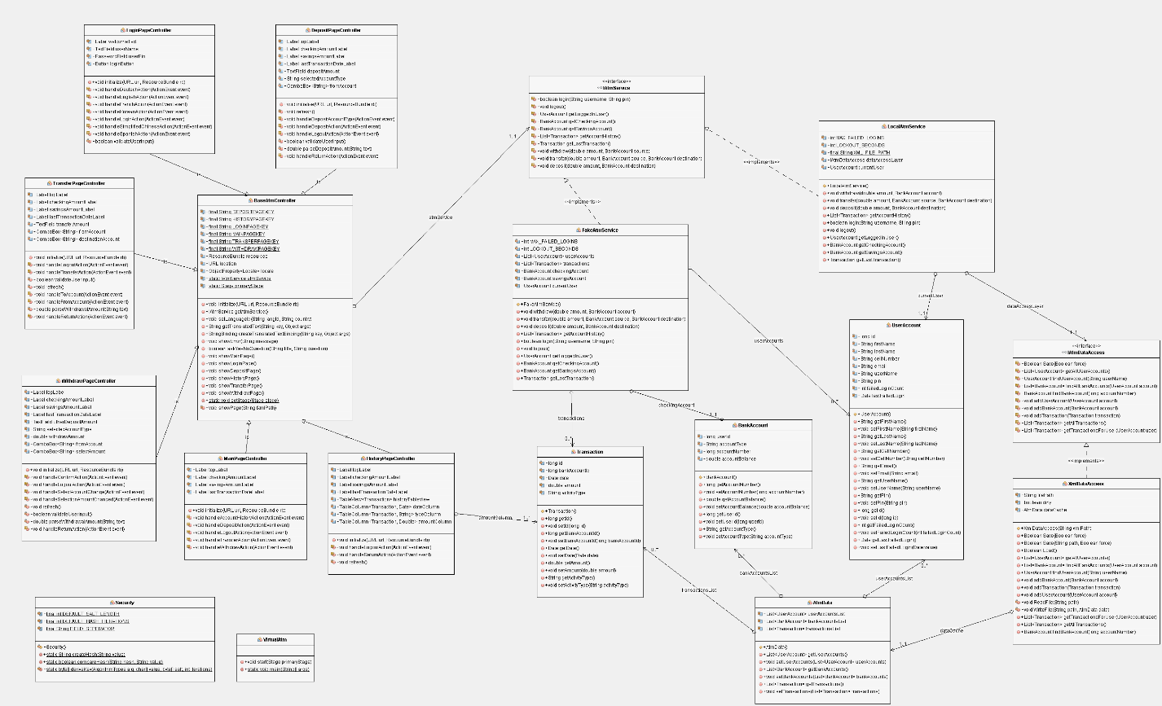

Figure 2. Full UML Diagram

### User Interface Layer

Since our project is based on the JavaFX framework, which follows the model-view-controller pattern, we needed to create “controller” classes to represent each page within our User Interface. This sub-diagram contains the most relationships and dependencies because the User Interface (UI) serves as the largest part of the program. The BaseAtmController class is at the center of every other class because it contains common functionality shared between each of the User Interface controllers.

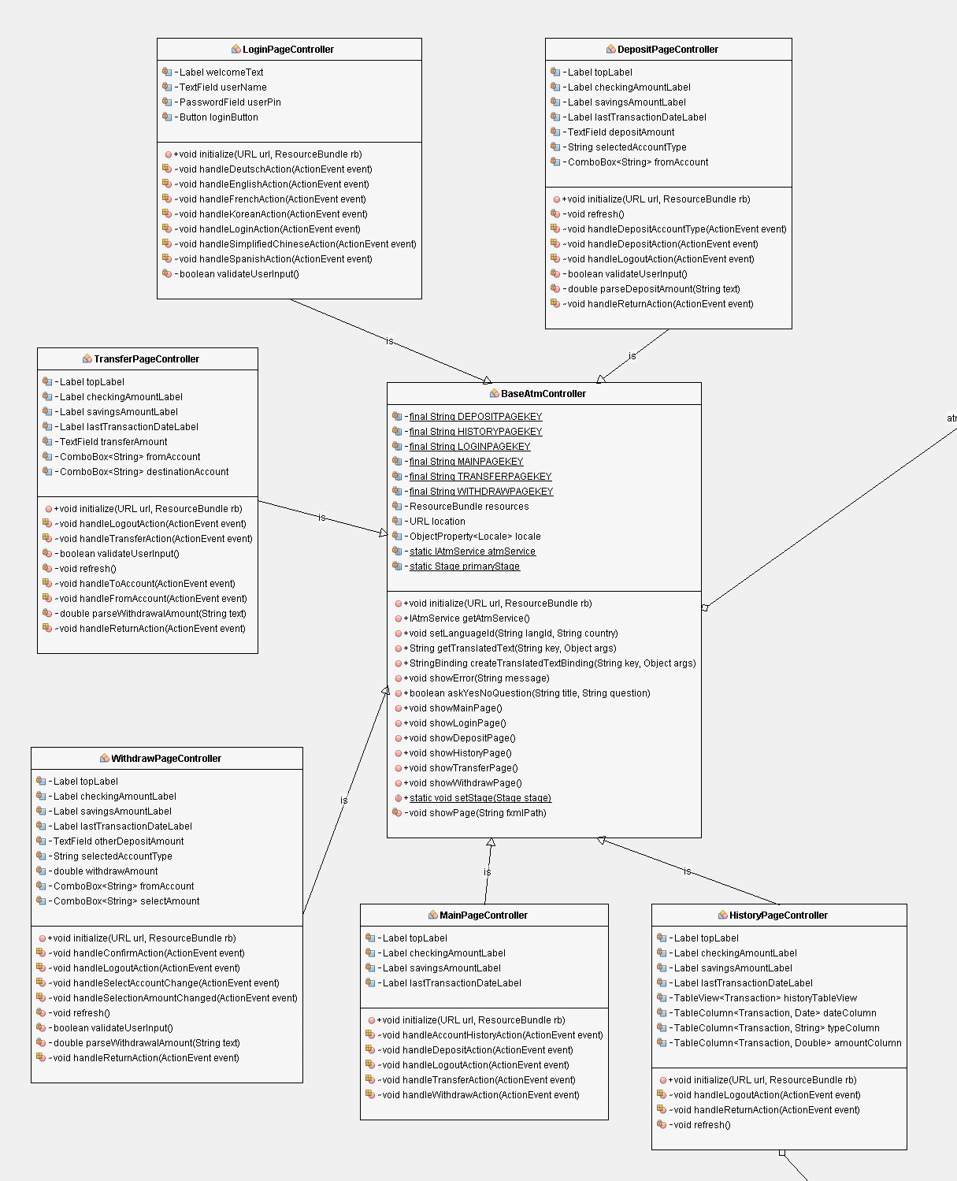

Figure 3. User Interface Layer UML

### Data Access Layer

The diagram below shows the combined data access layer and the data model classes for the application. We have defined the interface IAtmDataAccess in order to insulate the rest of the application from future changes to how the data stored. The XmlDataAccess class, which implements the IAtmDataAccess interface, is responsible for serialization and deserialization of the our data model to and from the XML file.

As mentioned previously, the three basic classes BankAccount, UserAccount, and Transaction make up the entire data model for the application. We chose to use these same three classes to store/retrieve information from the data access layer, so they have been incorporated into the IAtmDataAccess interface as well.

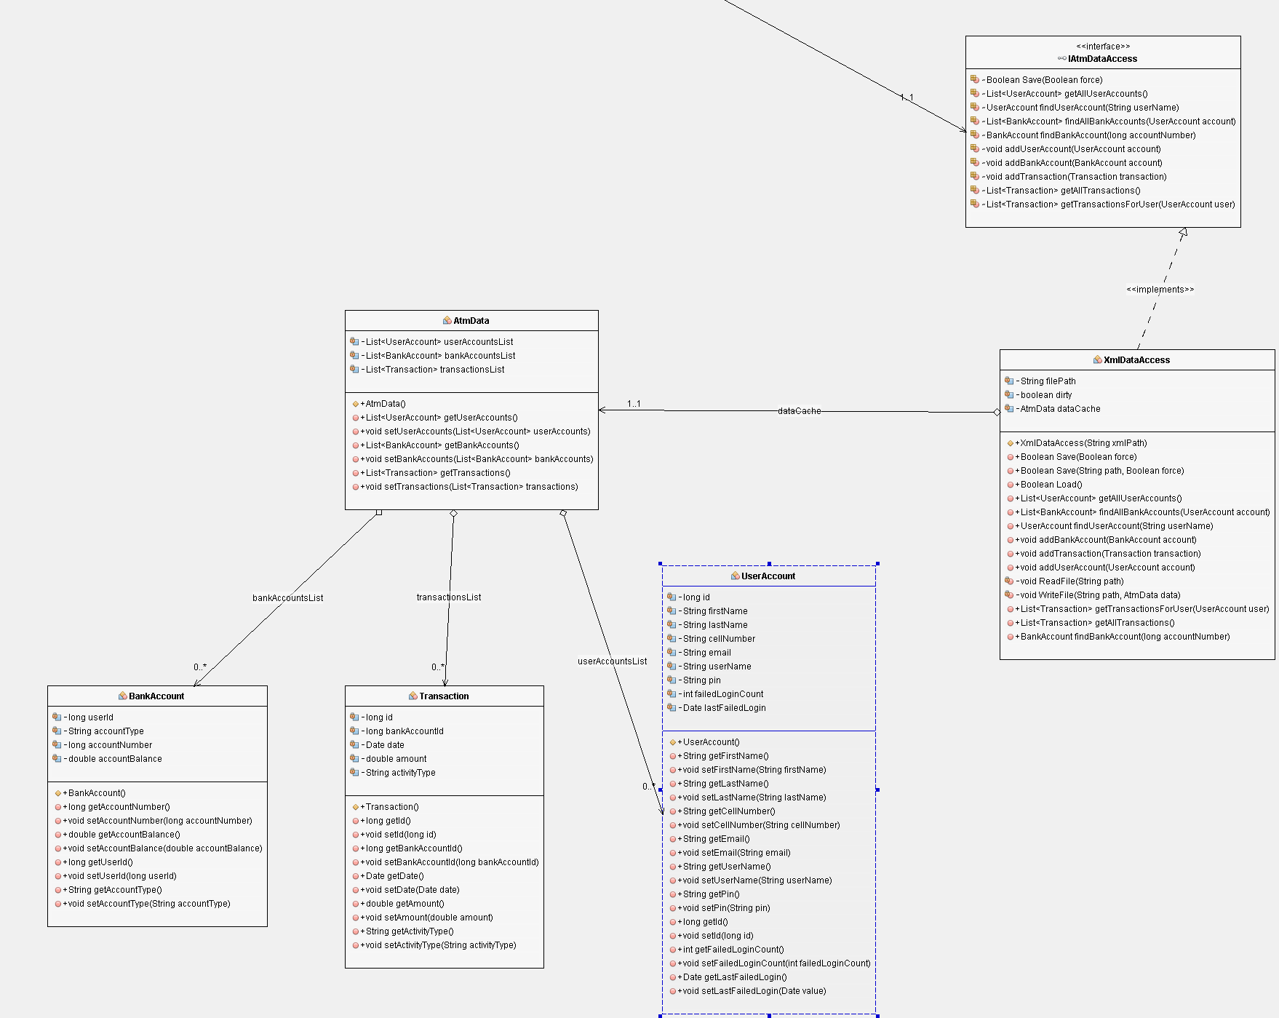

Figure 4. Data Model and Access Layer

## Alternate Design

The following are the graphics are from our initial stages of our design plan version 1. These graphics played a very important role during the design phase of the application. They paved a way that was initially not considered (using XML files to build our application). Most importantly, they helped us critically think about how our application will look like, function, and how the windows will communicate (dynamic or static windows).

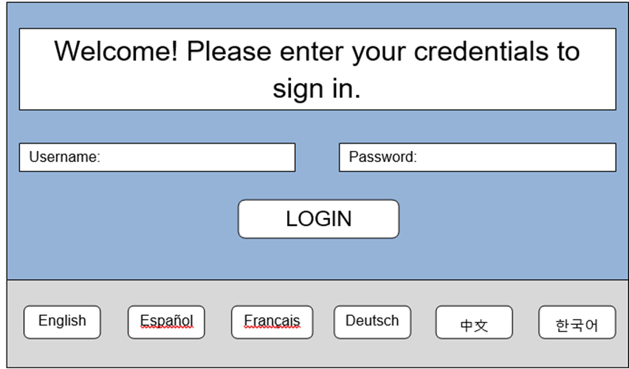

Figure 5.1 ATM Login Page (Original)

In Figure 5.1, the LoginPageController class will be called upon to load the ATM Login Page. If the username or password are incorrectly entered or missing, a message box containing an error message will appear (see Figure 5.2).

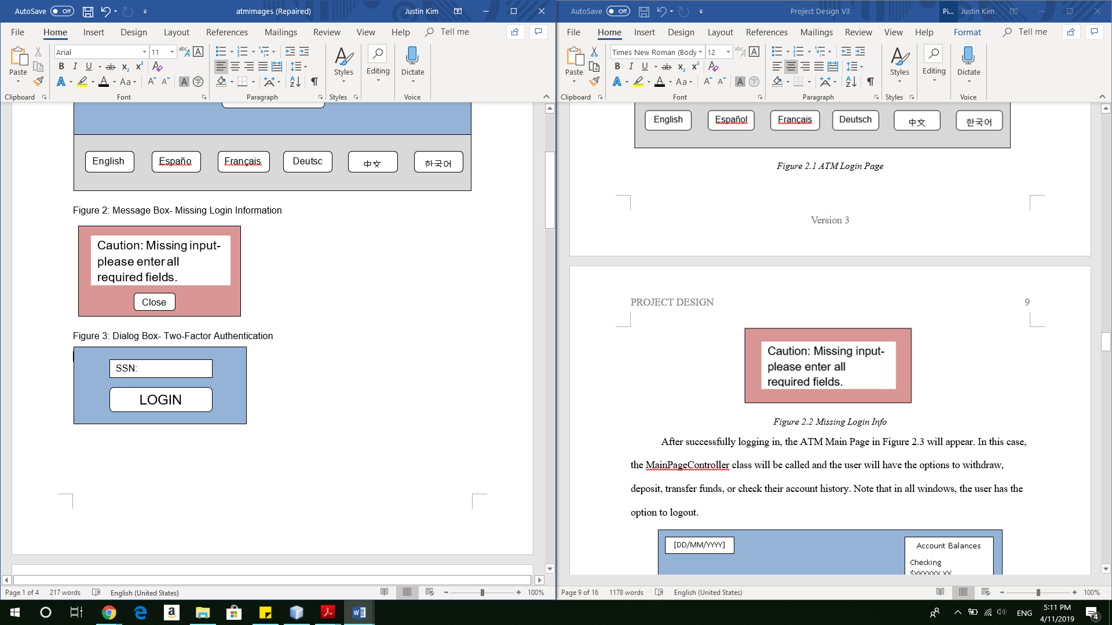

Figure 5.2 Missing Login Info (Original)

After successfully logging in, the ATM Main Page in Figure 5.3 will appear. In this case, the MainPageController class will be called and the user will have the options to withdraw, deposit, transfer funds, or check their account history. Note that in all windows, the user has the option to logout.

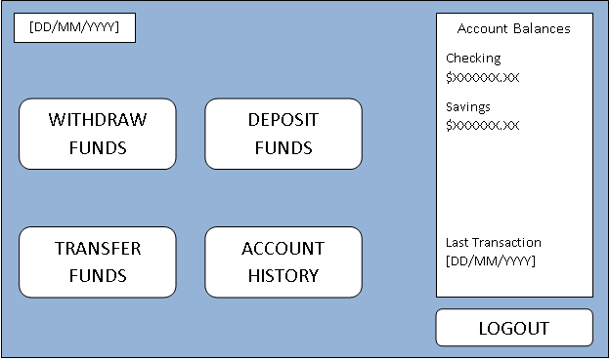

Figure 5.3 ATM Main Page (Original)

In the event the user clicks on the Deposit button, a Deposit page will appear (Figure 5.4) The deposit window allows for a customer to deposit cash into an account of their choosing (checking or savings). At this moment, an XML file will be loaded to the main controller and will display an interface to perform the intended operation. Note that the account balances are displayed in all transaction windows.

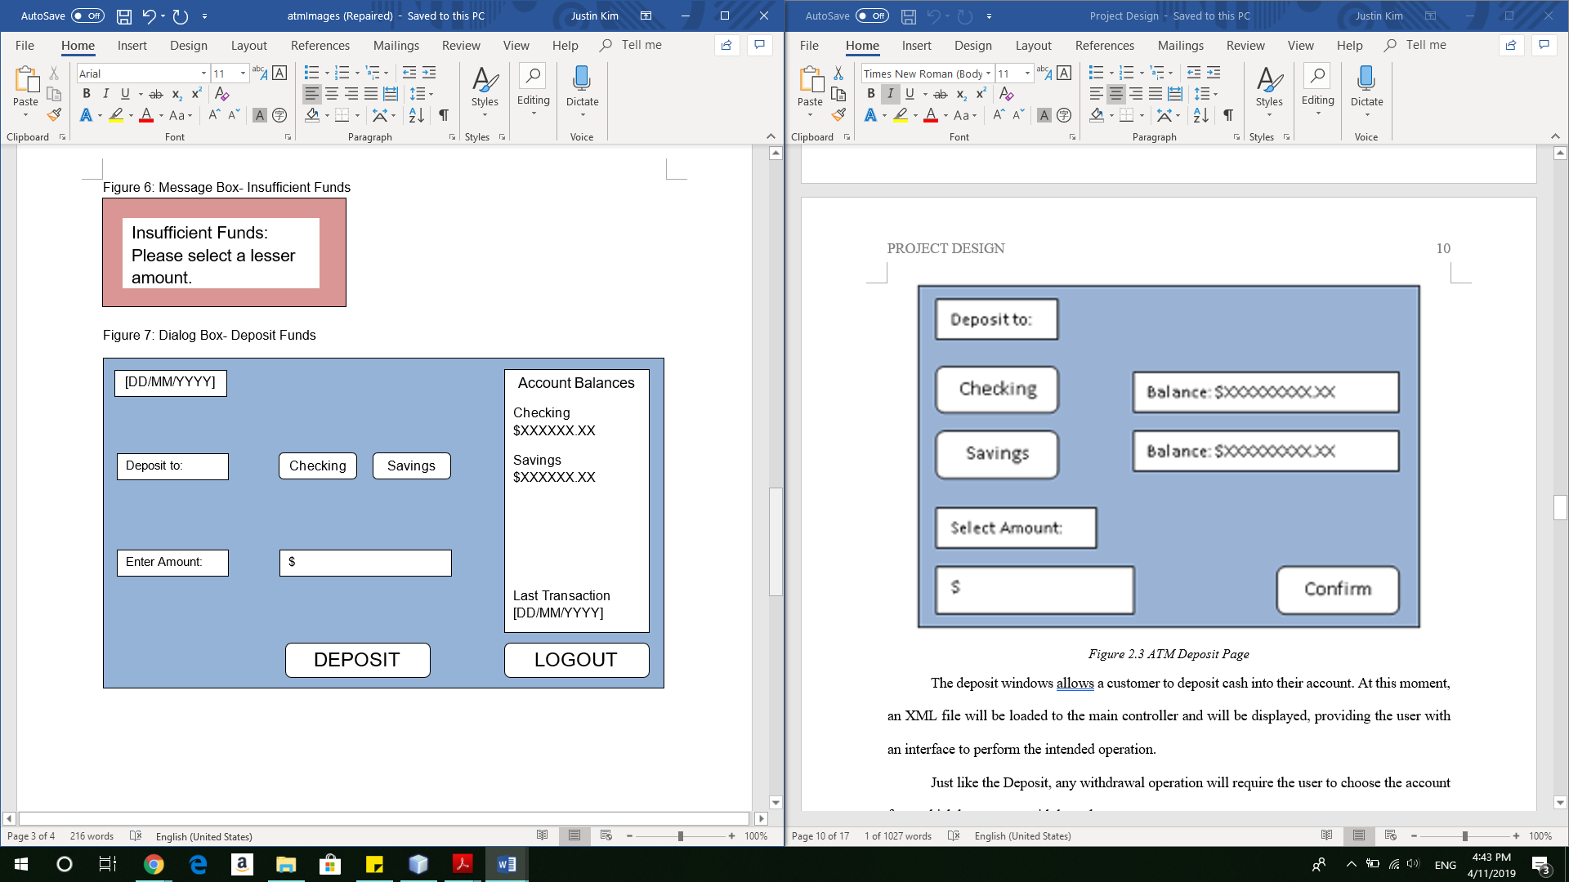

Figure 5.4 ATM Deposit Page

The Withdrawal Page shown in Figure 5.5, allows the user to withdraw cash from either account. This page allows the user to withdraw cash in increments of $20, $40, $60, $80, $100, or $200. The user is also able to enter in a specific amount (in increments of 20). If the account chosen to withdraw from has insufficient funds, a message box (Figure 2.6) will appear, letting the user know that there are not enough funds to withdraw.

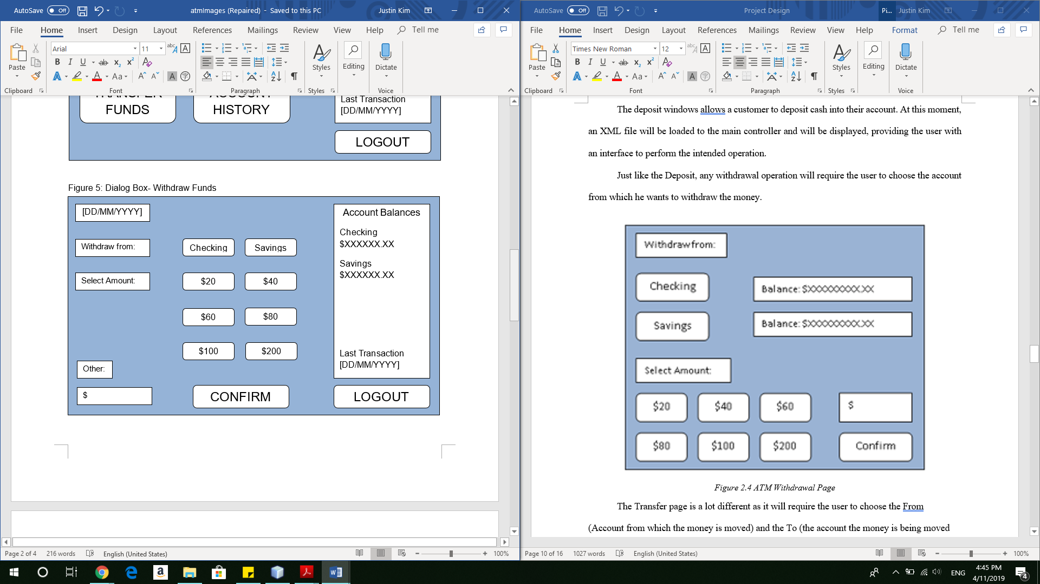

Figure 5.5 ATM Withdrawal Page

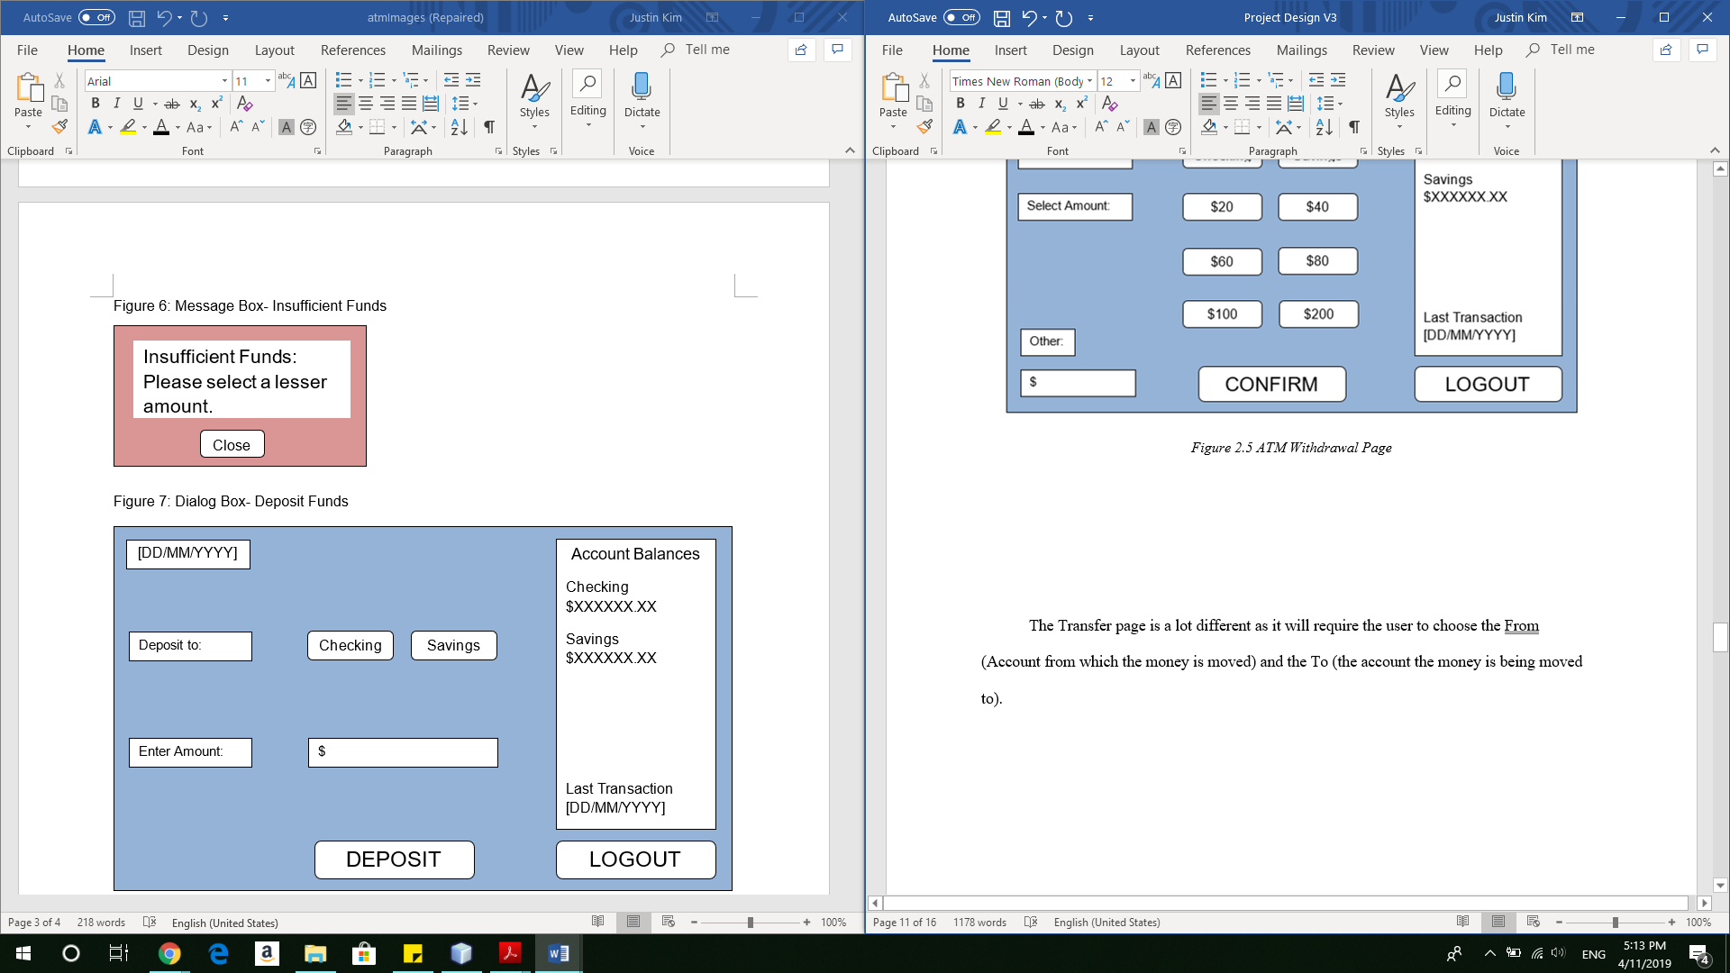

Figure 5.6 Insufficient Funds

The Transfer page (Figure 5.7) is a lot different as it will require the user to choose the From (Account from which the money is moved) and the To (the account the money is being moved to).

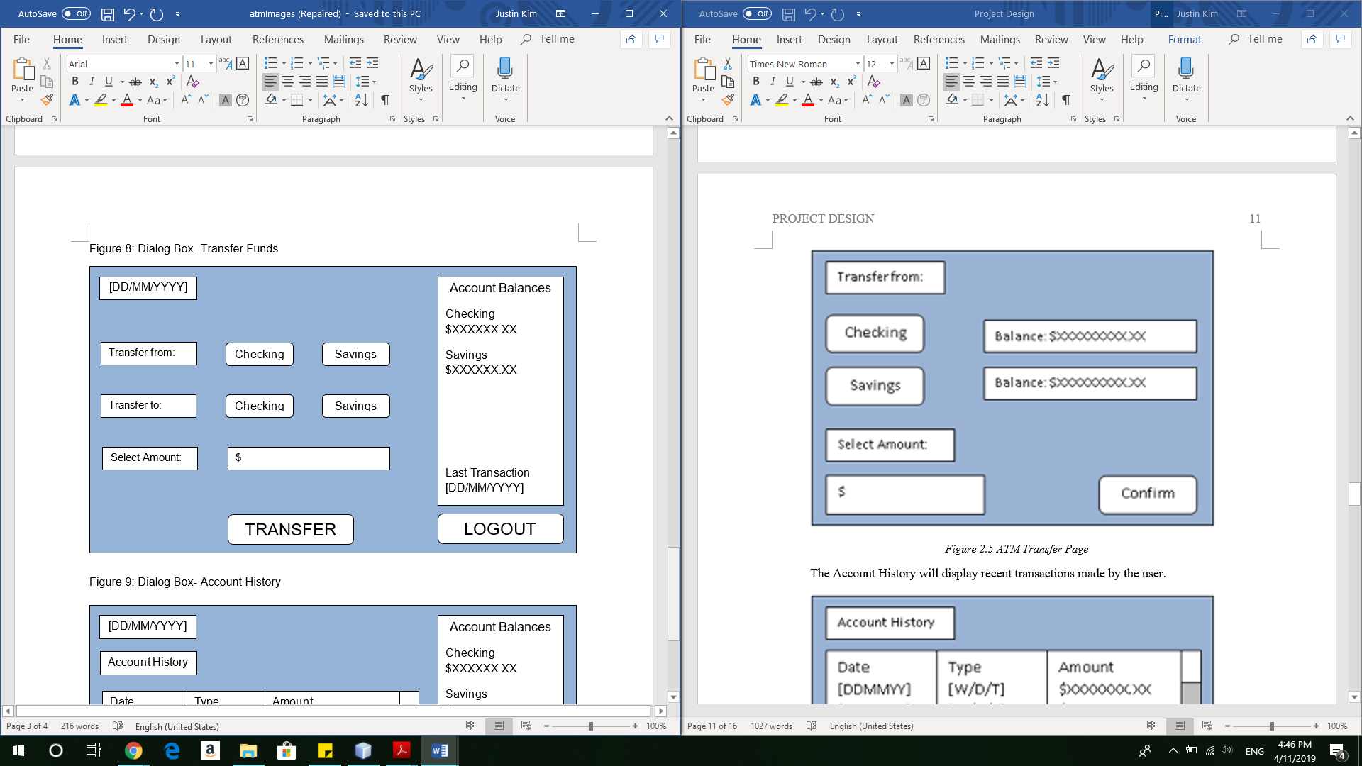

Figure 5.7 ATM Transfer Page

In Figure 5.8, the Account History page will display recent transactions made by the user, showing the date, type of transaction, and amount. There will be an option to return to the main page.

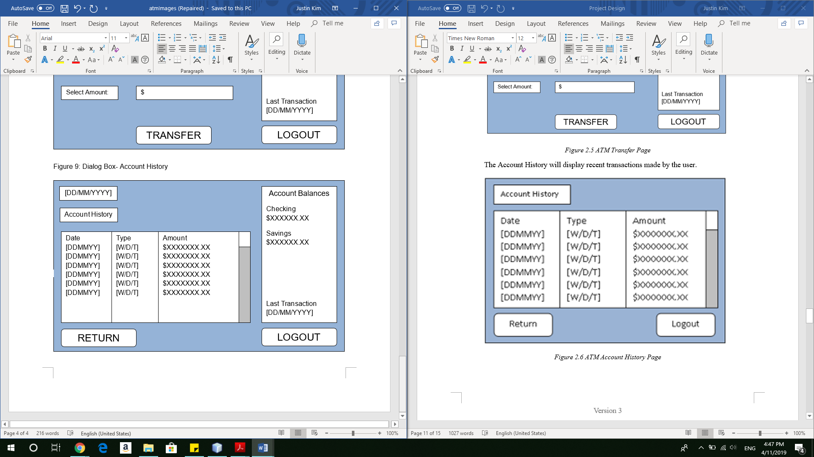

Figure 5.8 ATM Account History Page

# Development History

## Modifications

The items below detail the modifications and reflect any reevaluations made during this phase

* Project Plan
  + Submitted week 2, updated weeks 5 & 8
    - Requirement Specifications
      * Removed function and wording for creating a new user account
      * Removed function and wording for allowing user to login with phone number, password, account number, and last 4 digits of their SSN. User will now only login with username and PIN
* User’s Guide
  + Submitted week 3, updated weeks 5 & 8
    - * Updated screen shots for entire project to reflect actual GUI
* Test Plan
  + Submitted week 3, updated weeks 5 & 8
    - Added test cases for:
      * Viewing account history transactions
      * Withdrawing or depositing negative amounts (ex. $ -20)
      * Withdrawing more than the daily withdraw limit of $600
      * Retesting all cases in all languages
* Design Plan
  + Submitted week 6, updated week 7
    - * Updated the class/ interfaces/ fxml section to reflect the current attributes and methods for each respective class
      * Updated the complete UML diagram and each subsystem diagram
* Source Code
  + Submitted week 6, updated week 7
    - * Added XmlAtmDataAccess class to manage our XML based data
      * Added LocalAtmService class to handle “business logic” of our application
      * Modified IAtmService methods to return AtmServiceError’s rather than throwing exceptions
      * Added uitext.properties, uitext_de.properties, uitext_en.properties, uitext_es.properties, uitext_fr.properties, uitext_ko.properties, and uitext_zh_CN.properties to store all of the current text translations
      * Added new methods to BaseAtmController class for retrieving and binding translated text from our .properties files
      * Modified BaseAtmController to create an instance of LocalAtmService instead of our mockup FakeAtmService class
      * Added Security class to handle securely storing and matching user pin numbers
      * Modified LoginPage fxml and controller to dynamically change the user interface text based upon changes to the application default locale
      * Modified the DepositPage fxml and controller to retrieve translated text for all static text within buttons, labels, text boxes, and combo boxes
      * Modified the HistoryPage fxml and controller to retrieve translated text for all static text within buttons, labels, and table view columns
      * Modified the MainPage fxml and controller to retrieve translated text for all static text within buttons and labels
      * Modified the TransferPage fxml and controller to retrieve translated text for all static text within buttons, labels, text boxes, and combo boxes
      * Modified the WithdrawPage fxml and controller to retrieve translated text for all static text within buttons, labels, text boxes, and combo boxes
      * Scrubbed unneeded JavaFX control attributes from all controller classes
      * Added new class Timeline to BaseAtmController to implement inactivity timeout
      * Added new method handleTimer to BaseAtmController to start/stop the timeline, logout the user, and pop up an activity timeout error message
      * The new method returns to login page after the error message pops up
      * Added new method resetTimer to BaseAtmController to reset the timeline
      * Added calls to this new method into the UI Controller class for each page
      * Added translations to the transaction type columns on the Account History Page
      * Modified FakeAtmService to add maximum daily withdrawal limit
      * Modified LocalAtmService to add maximum daily withdrawal limit
      * Added new method for confirmation box for withdrawal, deposit and transfer message box
      * Modified uitext.properties, uitext_de.properties, uitext_en.properties, uitext_es.properties, uitext_fr.properties, uitext_ko.properties, and uitext_zh_CN.properties to store all of the current text translations

# Lessons Learned

# Design Strengths

# Limitations

# Suggestions for Future Improvement

While recognizing the limitations of our project, we believe we have largely achieved the main functionalities for our virtual ATM. If given the time and opportunity to make improvements, we would like to add functions for creating a new user and sending receipts via email and text. It would also be fit to add a cap for outrageously large deposits so that the code will trigger a StackOverflowError.